# Software Design Description

## Design Overview

* This document describes the technical and user interface design of **Information Management Website for High School**. It includes the architectural design, the detailed design of common functions and business functions.
* The architectural design describes the overall architecture of the system and the architecture of each main component and subsystem.
* The detailed design describes static and dynamic structure for each component and functions. It includes class diagrams, class explanations and sequence diagrams for each use cases.
* The database design describes the relationships between entities and details of each entity.
* Document overview:
* **Section 2:** The overall description of the system architectural design.
* **Section 3:** Component diagrams that describe the connection and integration of the system.
* **Section 4:** Detail design description, which includes class diagram, class explanation, and sequence diagram to describe the functions.
* **Section 5:** The user interface of application.
* **Section 6:** Database design with logical diagram.
* **Section 7:** The algorithms used for academic classification, considering honor, considering upgrading.

## System Architectural Design

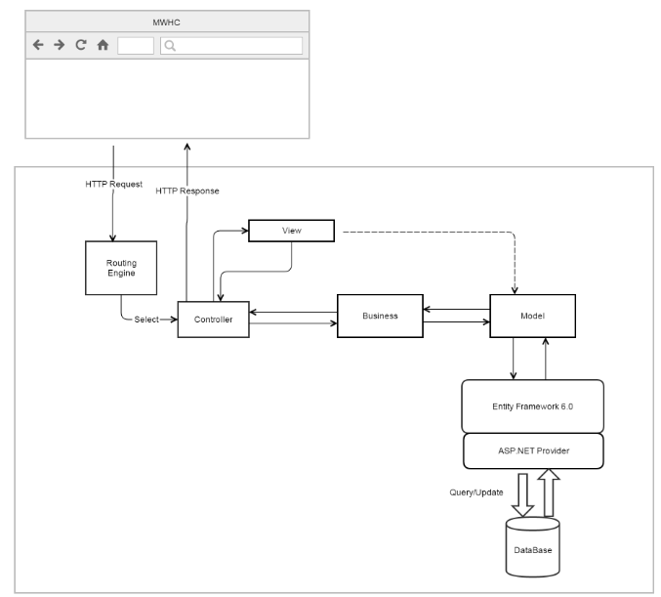

Figure 35: IMWHC System Architectural

We use MVC architecture style to develop IMWHC web. Specifically, customized it as convenient and suitable as possible to meet the customer’s requirement.

Controller: Receive requests from clients and transfers to Business to handle request then use processed result from Business to render View and return view to clients.

View: is responsible for display data from Model.

Model: generated by mapping database, Model is used to solve system data.

Business: Handles the business logic of the high school based on roles.

## Component Diagram

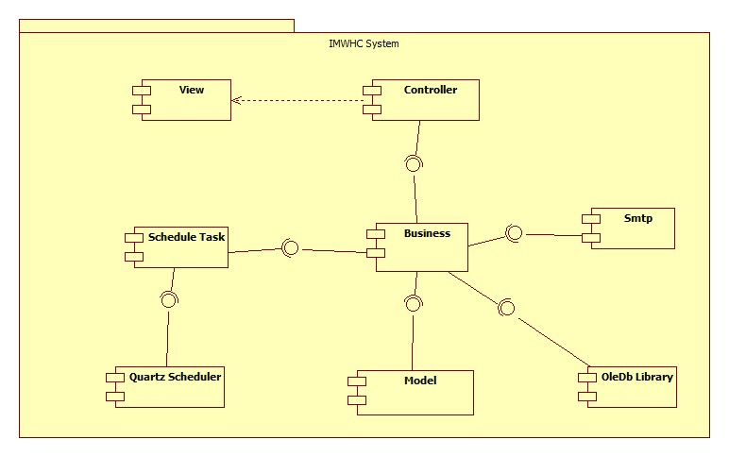

Figure 36: Component Diagram

|  |  |
| --- | --- |
| Component dictionary | |
| Component Name | Description |
| Controller | Contain all controllers in the system. |
| View | Contain all views in the system. |
| Business | Contain all business logic processing in the system. |
| Model | Entity Framework 6 mapping models. |
| OleDb library | Library that is used for importing or exporting excel files. |
| Smtp | Component is used to send asynchronous emails. |
| Schedule Task | Component contains modules that are used for executing sending notification emails to teachers, GPA calculating and academic classification on the end of semester. |
| Quartz Scheduler | A job scheduling library. |

Table 38: Component Dictionary

## Detailed Description

### Class Diagram

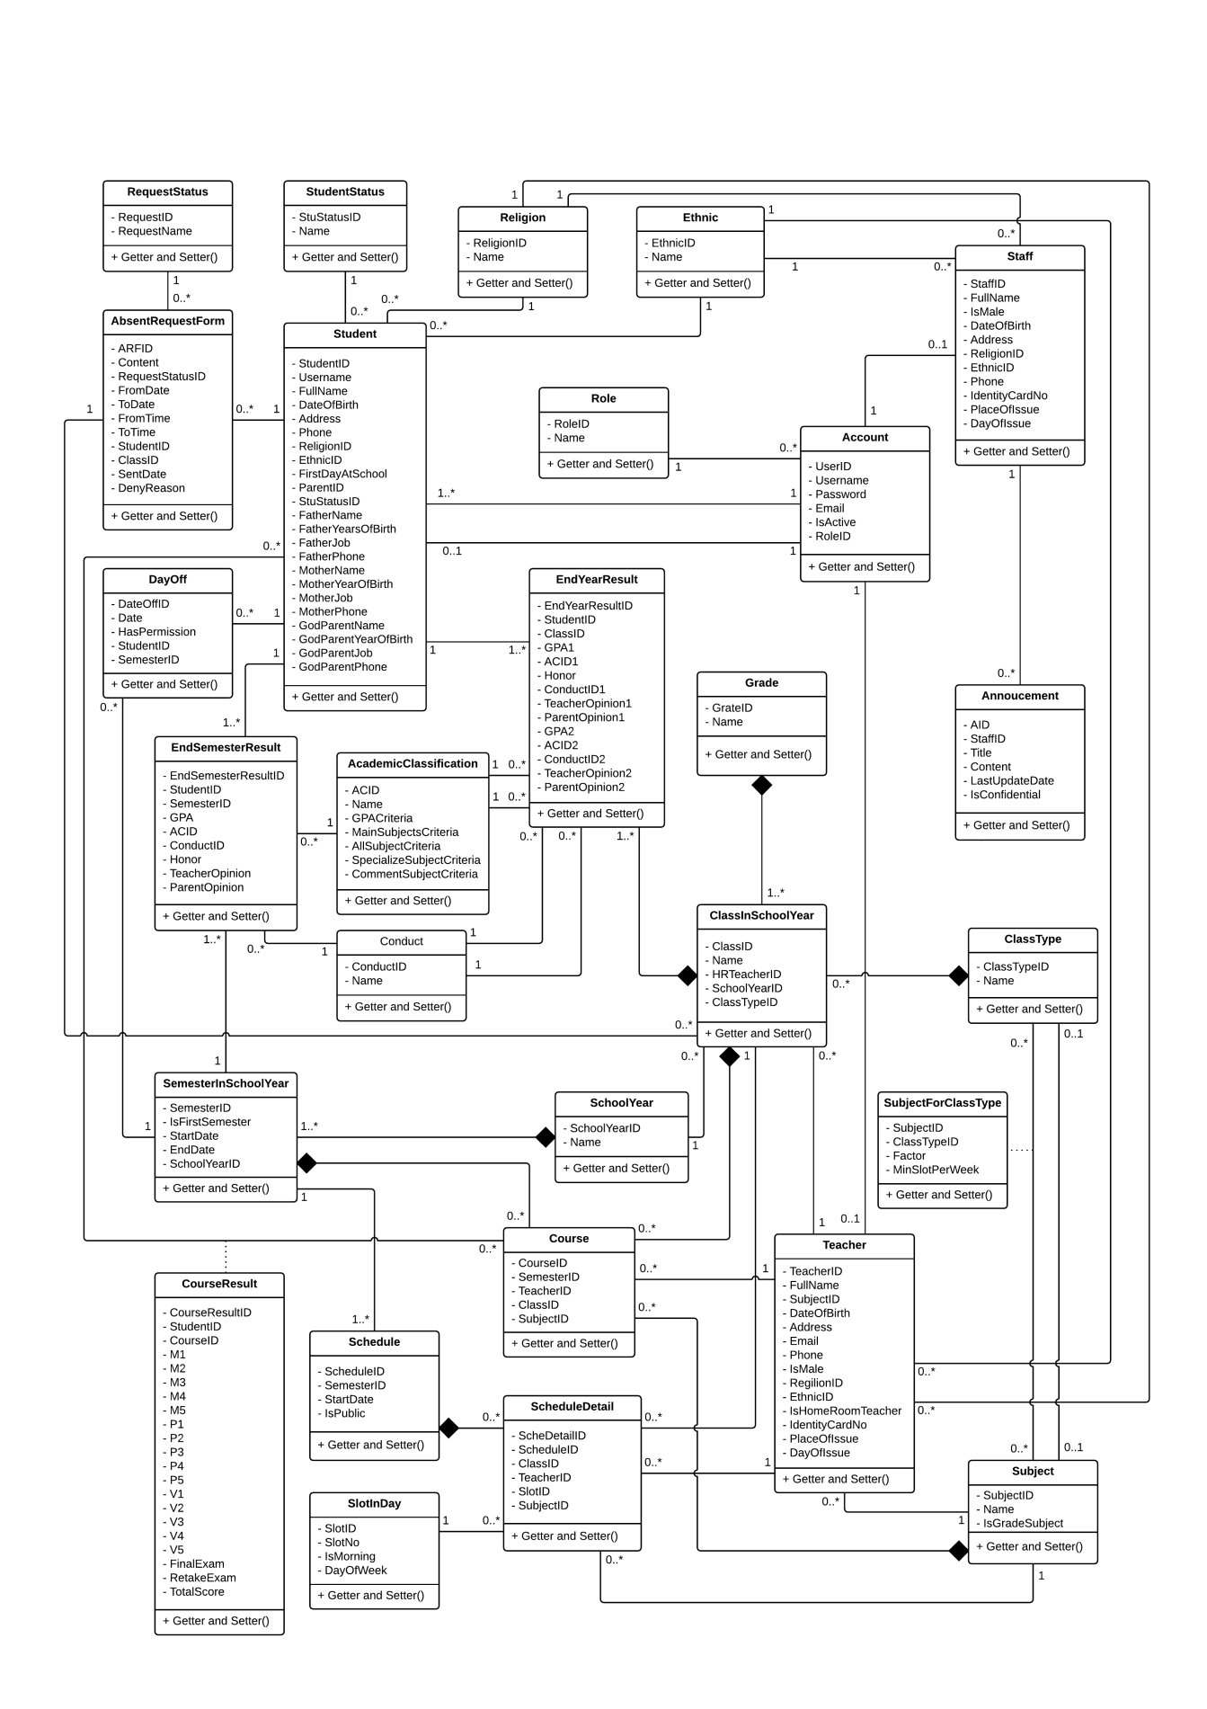

Figure 37: Class Diagram

### Class Diagram Explanation

#### Account

Attribute

|  |  |  |  |
| --- | --- | --- | --- |
| **Attribute** | **Type** | **Visibility** | **Description** |
| UserID | Integer | Private | Unique identifier of account. |
| Username | String | Private | Username of account. |
| Password | String | Private | Password of account. |
| Email | String | Private | Email of account. |
| IsActive | Boolean | Private | State of account. |
| RoleID | Integer | Private | Role of account. |

Method

|  |  |  |  |
| --- | --- | --- | --- |
| **Method** | **Return type** | **Visibility** | **Description** |
| Getter | Attribute type | Public | Get attribute value |
| Setter | Void | Public | Set value of attribute |

#### Student

Attribute

|  |  |  |  |
| --- | --- | --- | --- |
| **Attribute** | **Type** | **Visibility** | **Description** |
| StudentID | Integer | Private | Unique identifier of student. |
| Username | String | Private | Username of student. |
| FullName | US | Private | Full Name of student. |
| DateOfBirth | Date | Private | Birthday of student. |
| Address | US | Private | Address of student. |
| Phone | String | Private | Phone number of student. |
| ReligionID | Integer | Private | Unique identifier of religion. |
| EthnicID | Integer | Private | Unique identifier of ethnic. |
| FirstDayAtSchool | Date | Private | First day at school of student. |
| ParentID | Integer | Private | Unique identifier of parent. |
| StuStatusID | Integer | Private | Unique identifier of student status. |
| FatherName | US | Private | Father name of student. |
| FatherYearOfBirth | Date | Private | Father birthday of student. |
| FatherJob | US | Private | Father job of student. |
| FatherPhone | String | Private | Father phone number of student. |
| MotherName | US | Private | Mother name of student. |
| MotherYearOfBirth | Date | Private | Mother birthday of student. |
| MotherJob | US | Private | Mother job of student. |
| MotherPhone | String | Private | Mother phone number of student. |
| GodParentName | US | Private | God parent name of student. |
| GodParentYearOfBirth | Date | Private | God parent birthday of student. |
| GodParentJob | US | Private | God parent job of student. |
| GodParentPhone | String | Private | God parent phone number of student. |

Method

|  |  |  |  |
| --- | --- | --- | --- |
| **Method** | **Return type** | **Visibility** | **Description** |
| Getter | Attribute type | Public | Get attribute value |
| Setter | Void | Public | Set value of attribute |

#### Staff

Attribute

|  |  |  |  |
| --- | --- | --- | --- |
| **Attribute** | **Type** | **Visibility** | **Description** |
| StaffID | Integer | Private | Unique identifier of staff. |
| FullName | US | Private | Full Name of staff. |
| IsMale | Boolean | Private | Sex of staff. |
| DateOfBirth | Date | Private | Birthday of staff. |
| Address | US | Private | Address of staff. |
| ReligionID | Integer | Private | Unique identifier of religion. |
| EthnicID | Integer | Private | Unique identifier of ethnic. |
| Phone | String | Private | Phone number of staff. |
| IdentityCardNo | String | Private | IC number of staff. |
| PlaceOfIssue | US | Private | Place of issue of staff. |
| DayOfIssue | Date | Private | Day of issue of staff. |

Method

|  |  |  |  |
| --- | --- | --- | --- |
| **Method** | **Return type** | **Visibility** | **Description** |
| Getter | Attribute type | Public | Get attribute value |
| Setter | Void | Public | Set value of attribute |

#### Teacher

Attribute

|  |  |  |  |
| --- | --- | --- | --- |
| **Attribute** | **Type** | **Visibility** | **Description** |
| TeacherID | Integer | Private | Unique identifier of teacher. |
| FullName | US | Private | Full Name of teacher. |
| SubjectID | Integer | Private | Unique identifier of subject. |
| DateOfBirth | Date | Private | Birthday of teacher. |
| Address | US | Private | Address of teacher. |
| Email | String | Private | Email of teacher. |
| Phone | String | Private | Phone number of teacher. |
| IsMale | Boolean | Private | Sex of teacher. |
| ReligionID | Integer | Private | Unique identifier of religion. |
| EthnicID | Integer | Private | Unique identifier of ethnic. |
| IsHomeRoomTeacher | Boolean | Private | Teacher can become homeroom teacher or not. |
| IdentityCardNo | String | Private | IC number of teacher. |
| PlaceOfIssue | US | Private | Place of issue of teacher. |
| DayOfIssue | Date | Private | Day of issue of teacher. |

Method

|  |  |  |  |
| --- | --- | --- | --- |
| **Method** | **Return type** | **Visibility** | **Description** |
| Getter | Attribute type | Public | Get attribute value |
| Setter | Void | Public | Set value of attribute |

#### SemesterInSchoolYear

Attribute

|  |  |  |  |
| --- | --- | --- | --- |
| **Attribute** | **Type** | **Visibility** | **Description** |
| SemesterID | Integer | Private | Unique identifier of semester. |
| IsFirstSemester | Boolean | Private | Semester is 1st or 2nd. |
| StartDate | Date | Private | Date begin semester. |
| EndDate | Date | Private | Date end semester. |
| SchoolYearID | Integer | Private | Unique identifier of school year. |

Method

|  |  |  |  |
| --- | --- | --- | --- |
| **Method** | **Return type** | **Visibility** | **Description** |
| Getter | Attribute type | Public | Get attribute value |
| Setter | Void | Public | Set value of attribute |

#### SchoolYear

Attribute

|  |  |  |  |
| --- | --- | --- | --- |
| **Attribute** | **Type** | **Visibility** | **Description** |
| SchoolYearID | Integer | Private | Unique identifier of school year. |
| Name | US | Private | Name of school year. |

Method

|  |  |  |  |
| --- | --- | --- | --- |
| **Method** | **Return type** | **Visibility** | **Description** |
| Getter | Attribute type | Public | Get attribute value |
| Setter | Void | Public | Set value of attribute |

#### Schedule

Attribute

|  |  |  |  |
| --- | --- | --- | --- |
| **Attribute** | **Type** | **Visibility** | **Description** |
| ScheduleID | Integer | Private | Unique identifier of schedule. |
| SemesterID | Integer | Private | Unique identifier of semester. |
| StartDate | Date | Private | Date begin schedule. |
| IsPublic | Boolean | Private | Schedule is in public or not. |

Method

|  |  |  |  |
| --- | --- | --- | --- |
| **Method** | **Return type** | **Visibility** | **Description** |
| Getter | Attribute type | Public | Get attribute value |
| Setter | Void | Public | Set value of attribute |

#### ScheduleDetail

Attribute

|  |  |  |  |
| --- | --- | --- | --- |
| **Attribute** | **Type** | **Visibility** | **Description** |
| ScheDetailID | Integer | Private | Unique identifier of schedule detail. |
| ScheduleID | Integer | Private | Unique identifier of schedule. |
| ClassID | Integer | Private | Unique identifier of class. |
| TeacherID | Integer | Private | Unique identifier of teacher. |
| SlotID | Integer | Private | Unique identifier of slot. |
| SubjectID | Integer | Private | Unique identifier of subject. |

Method

|  |  |  |  |
| --- | --- | --- | --- |
| **Method** | **Return type** | **Visibility** | **Description** |
| Getter | Attribute type | Public | Get attribute value |
| Setter | Void | Public | Set value of attribute |

#### SlotInDay

Attribute

|  |  |  |  |
| --- | --- | --- | --- |
| **Attribute** | **Type** | **Visibility** | **Description** |
| SlotID | Integer | Private | Unique identifier of slot. |
| SlotNo | Integer | Private | Number of slot. |
| IsMorning | Boolean | Private | Slot is in morning or evening. |
| DayOfWeek | Integer | Private | Day of week. |

Method

|  |  |  |  |
| --- | --- | --- | --- |
| **Method** | **Return type** | **Visibility** | **Description** |
| Getter | Attribute type | Public | Get attribute value |
| Setter | Void | Public | Set value of attribute |

#### Subject

Attribute

|  |  |  |  |
| --- | --- | --- | --- |
| **Attribute** | **Type** | **Visibility** | **Description** |
| SubjectID | Integer | Private | Unique identifier of subject. |
| Name | US | Private | Name of subject. |
| IsGradeSubject | Boolean | Private | Subject is grade-base or comment-base. |

Method

|  |  |  |  |
| --- | --- | --- | --- |
| **Method** | **Return type** | **Visibility** | **Description** |
| Getter | Attribute type | Public | Get attribute value |
| Setter | Void | Public | Set value of attribute |

#### Course

Attribute

|  |  |  |  |
| --- | --- | --- | --- |
| **Attribute** | **Type** | **Visibility** | **Description** |
| CourseID | Integer | Private | Unique identifier of course. |
| SemesterID | Integer | Private | Unique identifier of semester. |
| TeacherID | Integer | Private | Unique identifier of teacher. |
| ClassID | Integer | Private | Unique identifier of class. |
| SubjectID | Integer | Private | Unique identifier of subject. |

Method

|  |  |  |  |
| --- | --- | --- | --- |
| **Method** | **Return type** | **Visibility** | **Description** |
| Getter | Attribute type | Public | Get attribute value |
| Setter | Void | Public | Set value of attribute |

#### CourseResult

Attribute

|  |  |  |  |
| --- | --- | --- | --- |
| **Attribute** | **Type** | **Visibility** | **Description** |
| CourseResultID | Integer | Private | Unique identifier of course result. |
| StudentID | Integer | Private | Unique identifier of student. |
| CourseID | Integer | Private | Unique identifier of course. |
| M1 | Float | Private | Oral test 1 grade. |
| M2 | Float | Private | Oral test 2 grade. |
| M3 | Float | Private | Oral test 3 grade. |
| M4 | Float | Private | Oral test 4 grade. |
| M5 | Float | Private | Oral test 5 grade. |
| P1 | Float | Private | 15 minutes test 1 grade. |
| P2 | Float | Private | 15 minutes test 2 grade. |
| P3 | Float | Private | 15 minutes test 3 grade. |
| P4 | Float | Private | 15 minutes test 4 grade. |
| P5 | Float | Private | 15 minutes test 5 grade. |
| V1 | Float | Private | 45 minutes test 1 grade. |
| V2 | Float | Private | 45 minutes test 2 grade. |
| V3 | Float | Private | 45 minutes test 3 grade. |
| V4 | Float | Private | 45 minutes test 4 grade. |
| V5 | Float | Private | 45 minutes test 5 grade. |
| FinalExam | Float | Private | Final grade. |
| RetakeExam | Float | Private | Retake grade. |
| TotalScore | Float | Private | Total grade. |

Method

|  |  |  |  |
| --- | --- | --- | --- |
| **Method** | **Return type** | **Visibility** | **Description** |
| Getter | Attribute type | Public | Get attribute value |
| Setter | Void | Public | Set value of attribute |

#### RequestStatus

Attribute

|  |  |  |  |
| --- | --- | --- | --- |
| **Attribute** | **Type** | **Visibility** | **Description** |
| RequestID | Integer | Private | Unique identifier of request status. |
| RequestName | US | Private | Name of request status. |

Method

|  |  |  |  |
| --- | --- | --- | --- |
| **Method** | **Return type** | **Visibility** | **Description** |
| Getter | Attribute type | Public | Get attribute value |
| Setter | Void | Public | Set value of attribute |

#### AbsenceRequestForm

Attribute

|  |  |  |  |
| --- | --- | --- | --- |
| **Attribute** | **Type** | **Visibility** | **Description** |
| ARFID | Integer | Private | Unique identifier of absence request form. |
| Content | US | Private | Content of absence request form. |
| RequestStatusID | Integer | Private | Unique identifier of request status. |
| FromDate | Date | Private | Date begin of absence request form. |
| ToDate | Date | Private | Date come of absence request form. |
| FromTime | Integer | Private | Time begin of absence request form. |
| ToTime | Integer | Private | Time come of absence request form. |
| StudentID | Integer | Private | Unique identifier of student. |
| ClassID | Integer | Private | Unique identifier of class. |
| SentDate | Datetime | Private | Date sent absence request form. |
| DenyReason | US | Private | Deny reason of absence request form. |

Method

|  |  |  |  |
| --- | --- | --- | --- |
| **Method** | **Return type** | **Visibility** | **Description** |
| Getter | Attribute type | Public | Get attribute value |
| Setter | Void | Public | Set value of attribute |

#### DayOff

Attribute

|  |  |  |  |
| --- | --- | --- | --- |
| **Attribute** | **Type** | **Visibility** | **Description** |
| DayOffID | Integer | Private | Unique identifier of day off. |
| Date | Date | Private | Date off. |
| HasPermission | Boolean | Private | Date off had pemission or not. |
| StudentID | Integer | Private | Unique identifier of student. |
| SemesterID | Integer | Private | Unique identifier of semester. |

Method

|  |  |  |  |
| --- | --- | --- | --- |
| **Method** | **Return type** | **Visibility** | **Description** |
| Getter | Attribute type | Public | Get attribute value |
| Setter | Void | Public | Set value of attribute |

#### EndSemesterResult

Attribute

|  |  |  |  |
| --- | --- | --- | --- |
| **Attribute** | **Type** | **Visibility** | **Description** |
| EndSemesterResultID | Integer | Private | Unique identifier of end semester result. |
| StudentID | Integer | Private | Unique identifier of student. |
| SemesterID | Integer | Private | Unique identifier of semester |
| GPA | Float | Private | Grade point average. |
| ACID | Integer | Private | Unique identifier of academic classification. |
| ConductID | Integer | Private | Unique identifier of conduct. |
| Honor | US | Private | Honor of end semester result. |
| TeacherOpinion | US | Private | Teacher opinion of end semester result. |
| ParentOpinion | US | Private | Parent opinion of end semester result. |

Method

|  |  |  |  |
| --- | --- | --- | --- |
| **Method** | **Return type** | **Visibility** | **Description** |
| Getter | Attribute type | Public | Get attribute value |
| Setter | Void | Public | Set value of attribute |

#### Conduct

Attribute

|  |  |  |  |
| --- | --- | --- | --- |
| **Attribute** | **Type** | **Visibility** | **Description** |
| ConductID | Integer | Private | Unique identifier of conduct. |
| Name | US | Private | Name of conduct. |

Method

|  |  |  |  |
| --- | --- | --- | --- |
| **Method** | **Return type** | **Visibility** | **Description** |
| Getter | Attribute type | Public | Get attribute value |
| Setter | Void | Public | Set value of attribute |

#### AcademicClassification

Attribute

|  |  |  |  |
| --- | --- | --- | --- |
| **Attribute** | **Type** | **Visibility** | **Description** |
| ACID | Integer | Private | Unique identifier of academic classification. |
| Name | US | Private | Nam of academic classification. |
| GPACriteria | Float | Private | GPA criteria of academic classification. |
| MainSubjectsCriteria | Float | Private | Main subjects criteria of academic classification. |
| AllSubjectCriteria | Float | Private | All subject criteria of academic classification. |
| SpecializeSubjectCriteria | Float | Private | Special subject criteria of academic classification. |
| CommentCriteria | Float | Private | Comment subject criteria of academic classification. |

Method

|  |  |  |  |
| --- | --- | --- | --- |
| **Method** | **Return type** | **Visibility** | **Description** |
| Getter | Attribute type | Public | Get attribute value |
| Setter | Void | Public | Set value of attribute |

#### Grade

Attribute

|  |  |  |  |
| --- | --- | --- | --- |
| **Attribute** | **Type** | **Visibility** | **Description** |
| GradeID | Integer | Private | Unique identifier of grade. |
| Name | US | Private | Name of grade. |

Method

|  |  |  |  |
| --- | --- | --- | --- |
| **Method** | **Return type** | **Visibility** | **Description** |
| Getter | Attribute type | Public | Get attribute value |
| Setter | Void | Public | Set value of attribute |

#### ClassInSchoolYear

Attribute

|  |  |  |  |
| --- | --- | --- | --- |
| **Attribute** | **Type** | **Visibility** | **Description** |
| ClassID | Integer | Private | Unique identifier of class. |
| Name | US | Private | Name of class. |
| HRTeacherID | Integer | Private | Unique identifier of teacher. |
| SchoolYearID | Integer | Private | Unique identifier of school year. |
| ClassTypeID | Integer | Private | Unique identifier of class type. |

Method

|  |  |  |  |
| --- | --- | --- | --- |
| **Method** | **Return type** | **Visibility** | **Description** |
| Getter | Attribute type | Public | Get attribute value |
| Setter | Void | Public | Set value of attribute |

#### ClassType

Attribute

|  |  |  |  |
| --- | --- | --- | --- |
| **Attribute** | **Type** | **Visibility** | **Description** |
| ClassTypeID | Integer | Private | Unique identifier of class type. |
| Name | US | Private | Name of class type. |

Method

|  |  |  |  |
| --- | --- | --- | --- |
| **Method** | **Return type** | **Visibility** | **Description** |
| Getter | Attribute type | Public | Get attribute value |
| Setter | Void | Public | Set value of attribute |

#### SubjectForClassType

Attribute

|  |  |  |  |
| --- | --- | --- | --- |
| **Attribute** | **Type** | **Visibility** | **Description** |
| SubjectID | Integer | Private | Unique identifier of subject. |
| ClassTypeID | Integer | Private | Unique identifier of class type. |
| Factor | US | Private | Factor of subject for class type. |
| MinSlotPerWeek | Float | Private | Minimum slot per week. |

Method

|  |  |  |  |
| --- | --- | --- | --- |
| **Method** | **Return type** | **Visibility** | **Description** |
| Getter | Attribute type | Public | Get attribute value |
| Setter | Void | Public | Set value of attribute |

#### Announcement

Attribute

|  |  |  |  |
| --- | --- | --- | --- |
| **Attribute** | **Type** | **Visibility** | **Description** |
| AID | Integer | Private | Unique identifier of announcement. |
| StaffID | Integer | Private | Unique identifier of staff. |
| Title | US | Private | Title of announcement. |
| Content | US | Private | Content of announcement. |
| LastUpdateDate | Datetime | Private | Last date update of announcement. |
| IsConfidential | Boolean | Private | Announcement is confidential or not. |

Method

|  |  |  |  |
| --- | --- | --- | --- |
| **Method** | **Return type** | **Visibility** | **Description** |
| Getter | Attribute type | Public | Get attribute value |
| Setter | Void | Public | Set value of attribute |

#### Role

Attribute

|  |  |  |  |
| --- | --- | --- | --- |
| **Attribute** | **Type** | **Visibility** | **Description** |
| RoleID | Integer | Private | Unique identifier of role. |
| Name | US | Private | Nam of role. |

Method

|  |  |  |  |
| --- | --- | --- | --- |
| **Method** | **Return type** | **Visibility** | **Description** |
| Getter | Attribute type | Public | Get attribute value |
| Setter | Void | Public | Set value of attribute |

#### StudentStatus

Attribute

|  |  |  |  |
| --- | --- | --- | --- |
| **Attribute** | **Type** | **Visibility** | **Description** |
| StuStatusID | Integer | Private | Unique identifier of student status. |
| Name | US | Private | Name of student status. |

Method

|  |  |  |  |
| --- | --- | --- | --- |
| **Method** | **Return type** | **Visibility** | **Description** |
| Getter | Attribute type | Public | Get attribute value |
| Setter | Void | Public | Set value of attribute |

#### Religion

Attribute

|  |  |  |  |
| --- | --- | --- | --- |
| **Attribute** | **Type** | **Visibility** | **Description** |
| ReligionID | Integer | Private | Unique identifier of religion. |
| Name | US | Private | Name of religion. |

Method

|  |  |  |  |
| --- | --- | --- | --- |
| **Method** | **Return type** | **Visibility** | **Description** |
| Getter | Attribute type | Public | Get attribute value |
| Setter | Void | Public | Set value of attribute |

#### Ethnic

Attribute

|  |  |  |  |
| --- | --- | --- | --- |
| **Attribute** | **Type** | **Visibility** | **Description** |
| EthnicID | Integer | Private | Unique identifier of ethnic. |
| Name | US | Private | Name of ethnic. |

Method

|  |  |  |  |
| --- | --- | --- | --- |
| **Method** | **Return type** | **Visibility** | **Description** |
| Getter | Attribute type | Public | Get attribute value |
| Setter | Void | Public | Set value of attribute |

#### EndYearResult

Attribute

|  |  |  |  |
| --- | --- | --- | --- |
| **Attribute** | **Type** | **Visibility** | **Description** |
| EndYearResultID | Integer | Private | Unique identifier of end year result. |
| StudentID | Integer | Private | Unique identifier of student. |
| ClassID | Integer | Private | Unique identifier of class. |
| GPA1 | Float | Private | Grade point average 1. |
| ACID1 | Integer | Private | Unique identifier of academic classification 1. |
| Honor | US | Private | Honor of end year result. |
| ConductID1 | Integer | Private | Unique identifier of conduct 1. |
| TeacherOpinion1 | US | Private | Teacher opinion of end year result 1. |
| ParentOpinion1 | US | Private | Parent opinion of end year result 1. |
| GPA2 | Float | Private | Grade point average 2. |
| ACID2 | Integer | Private | Unique identifier of academic classification 2. |
| ConductID2 | Integer | Private | Unique identifier of conduct 2. |
| TeacherOpinion2 | US | Private | Teacher opinion of end year result 2. |
| ParentOpinion2 | US | Private | Parent opinion of end year result 2. |

Method

|  |  |  |  |
| --- | --- | --- | --- |
| **Method** | **Return type** | **Visibility** | **Description** |
| Getter | Attribute type | Public | Get attribute value |
| Setter | Void | Public | Set value of attribute |

### Interaction Diagram

#### <Guest> Login

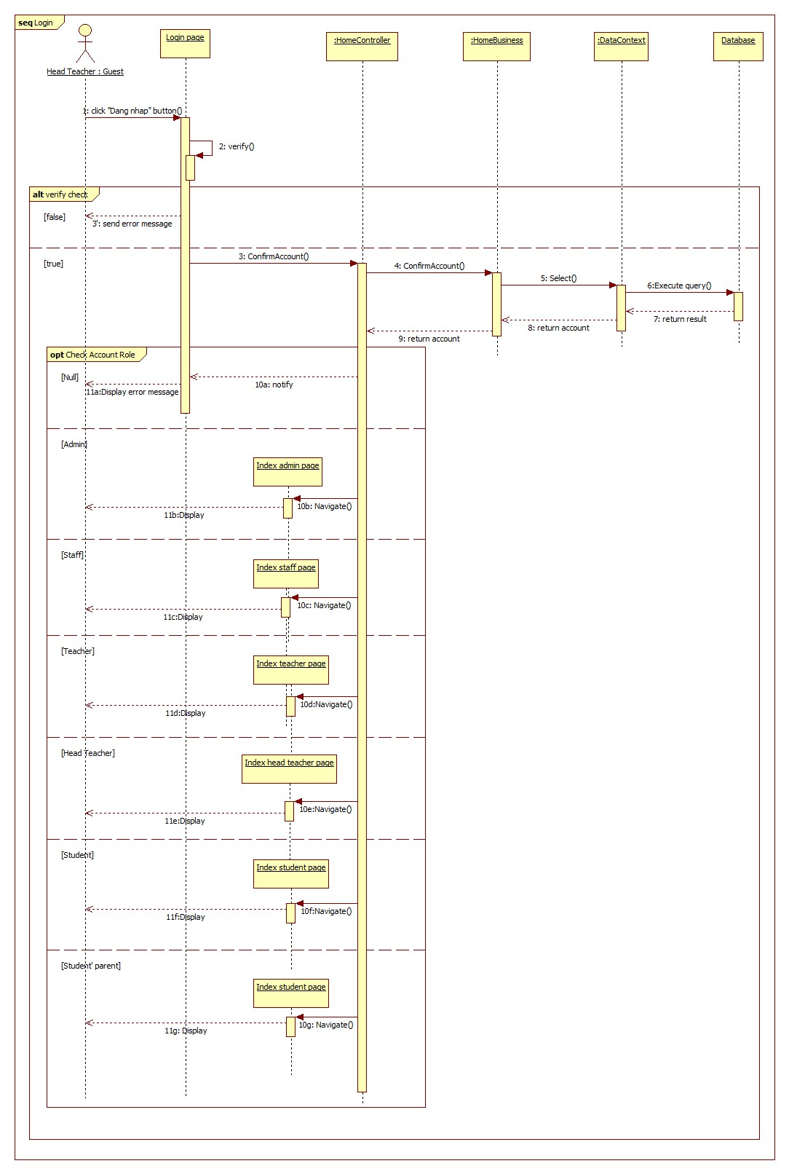**Summary:** This diagram shows how guest login into system.

Figure 38: Sequence Diagram <Guest> Login

#### <Admin> Configuration School Year

**Summary:** This diagram shows how admin configurations new school year into system.

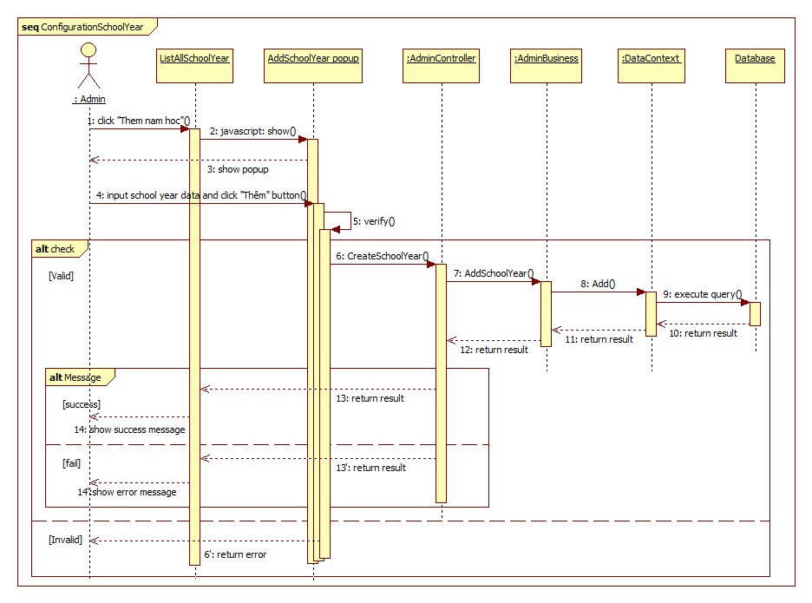

Figure 39: Sequence Diagram <Admin> Configuration School Year

#### <Admin> Add Class

**Summary:** This diagram shows how admin add new class into system.

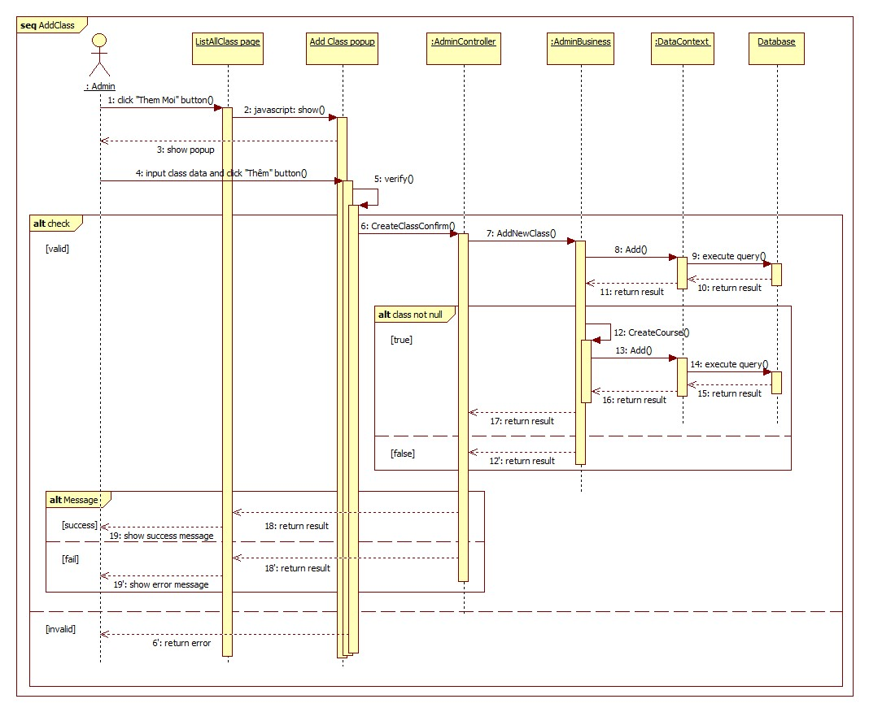

Figure 40: Sequence Diagram <Staff> Add Class

#### <Admin> Add Student Profile

**Summary:** This diagram shows how admin add new student into system.



Figure 41: Sequence Diagram <Admin> Add Student Profile

#### <Admin> Import Student List

**Summary:** This diagram shows how admin import student list into system.

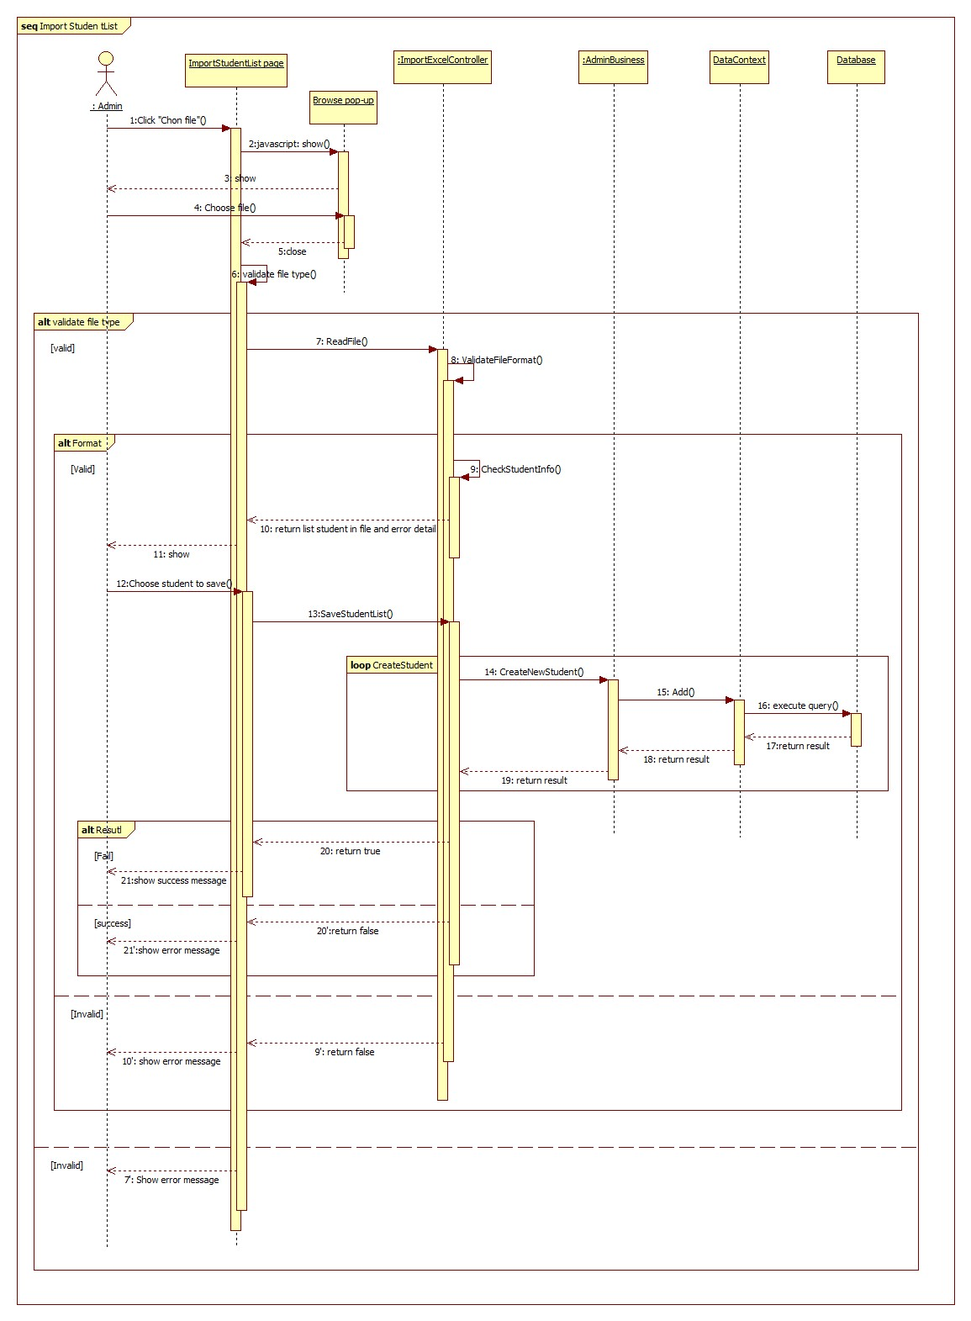

Figure 42: Sequence Diagram <Admin> Import Student List

#### <Admin> Export Student List

**Summary:** This diagram shows how admin export student list from system.

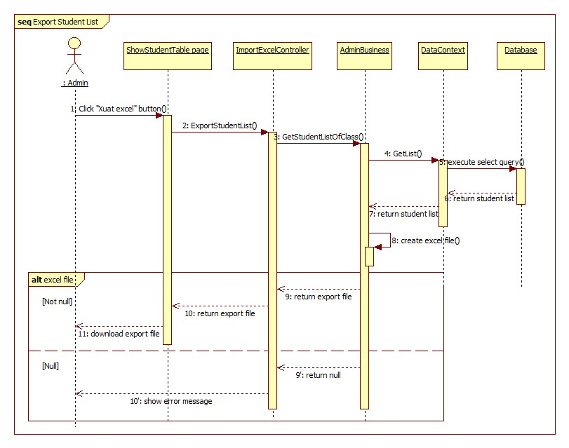

Figure 43: Sequence Diagram<Admin> Export Student List

#### <Admin> Add Teacher Profile

**Summary:** This diagram shows how admin add new teacher into system.

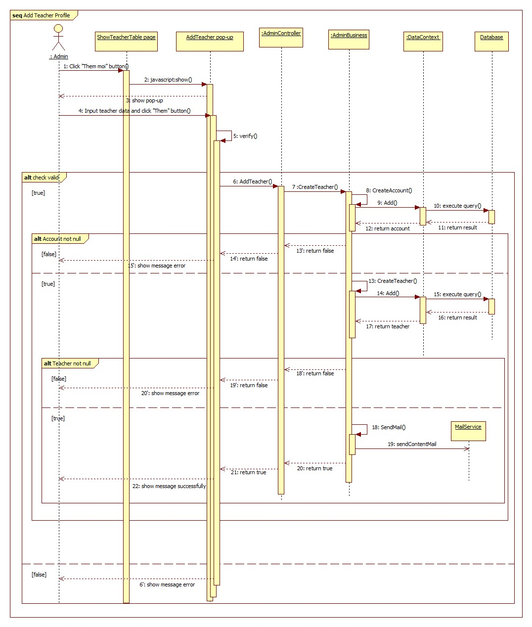

Figure 44: Sequence Diagram <Admin> Add Teacher Profile

#### <Admin> Edit Student Profile

**Summary:** This diagram shows how admin edit student information into system.



Figure 45: Sequence Diagram <Admin> Edit Student Profile

#### <Staff> Add Announcement

**Summary:** This diagram shows how staff add announcement into system.

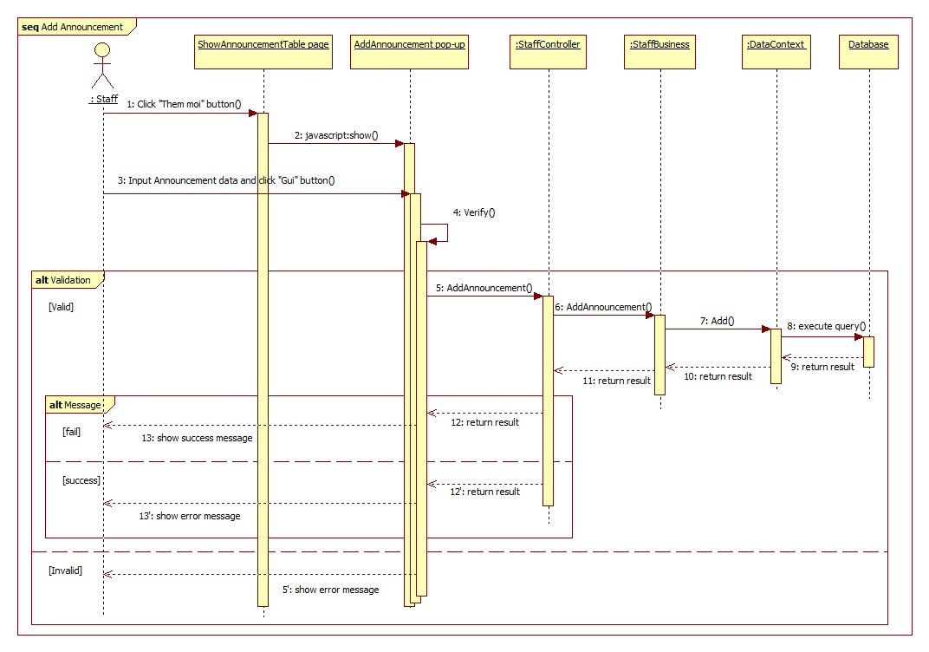

Figure 46: Sequence Diagram <Staff> Add Announcement

#### <Staff> Add Schedule

**Summary:** This diagram shows how staff add schedule into system.

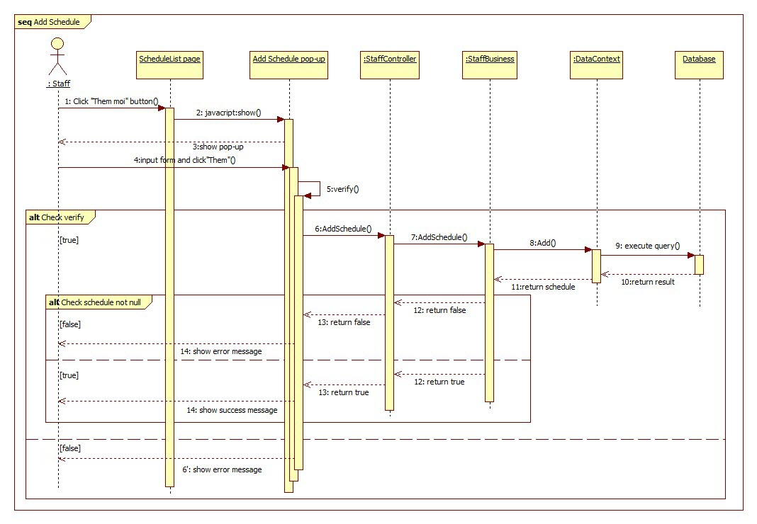

Figure 47: Sequence Diagram <Staff> Add Schedule

#### <Staff> Update Schedule Detail

**Summary:** This diagram shows how staff shows detail of schedule from system.

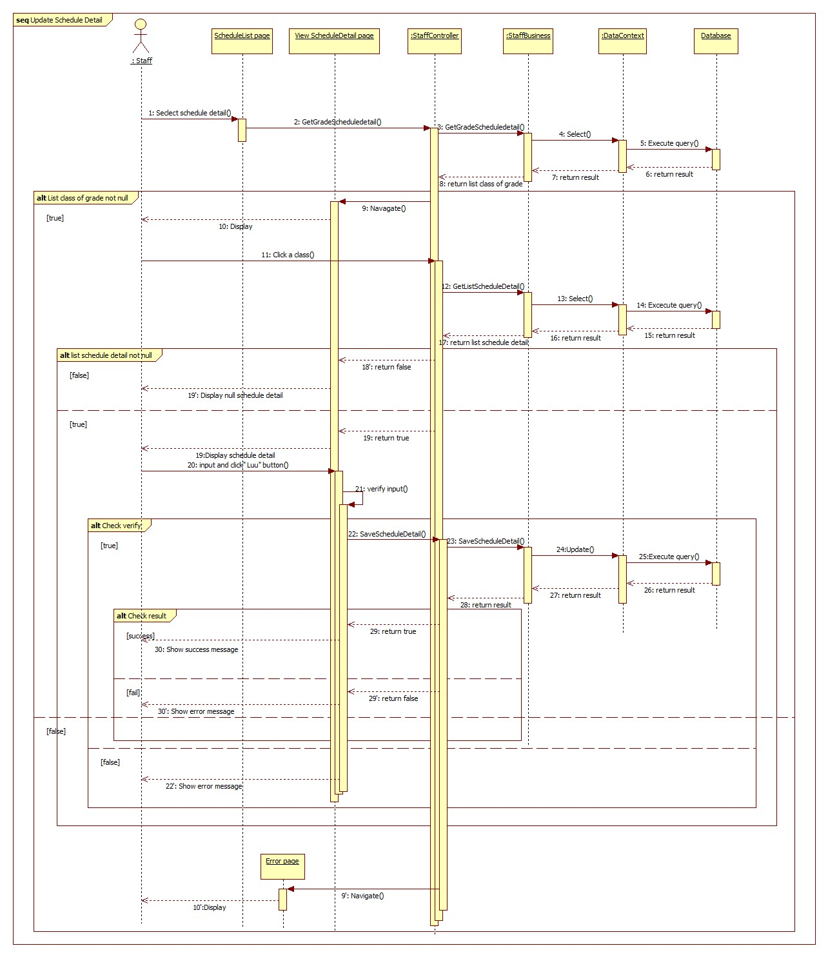

Figure 48: Sequence Diagram <Staff> Update Schedule Detail

#### <Staff> Delete Schedule

**Summary:** This diagram shows how staff delete schedule from system.

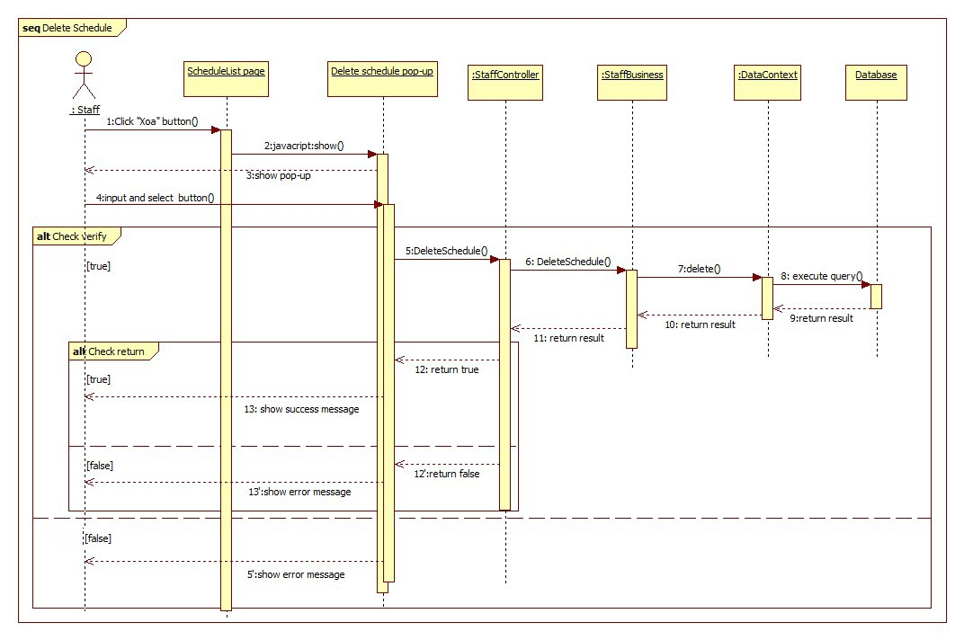

Figure 49: Sequence Diagram <Staff> Delete Schedule

#### <Head Teacher> View Statistic of Grade

**Summary:** This diagram shows how head teacher view statistic of grade.

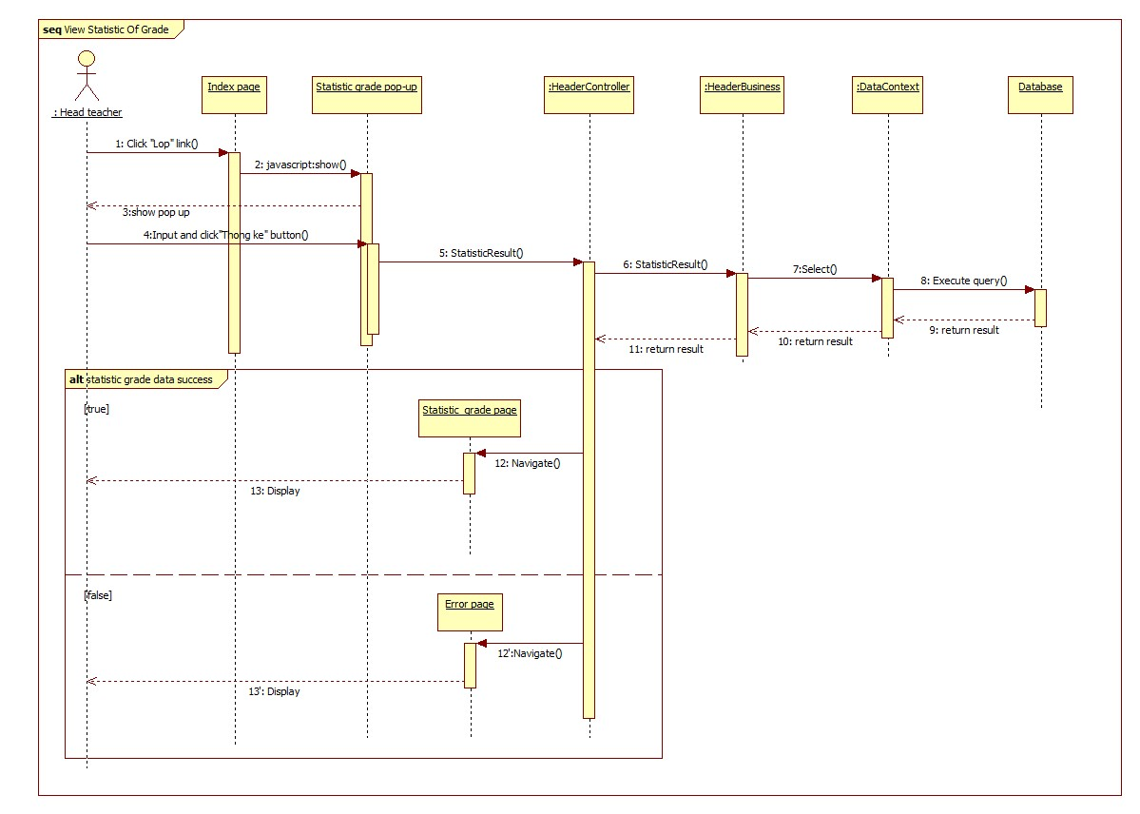

Figure 50: Sequence Diagram <Head Teacher> View Statistic of Grade

#### < Subject Teacher > Edit Gradebook

**Summary:** This diagram shows how subject teacher edit gradebook.

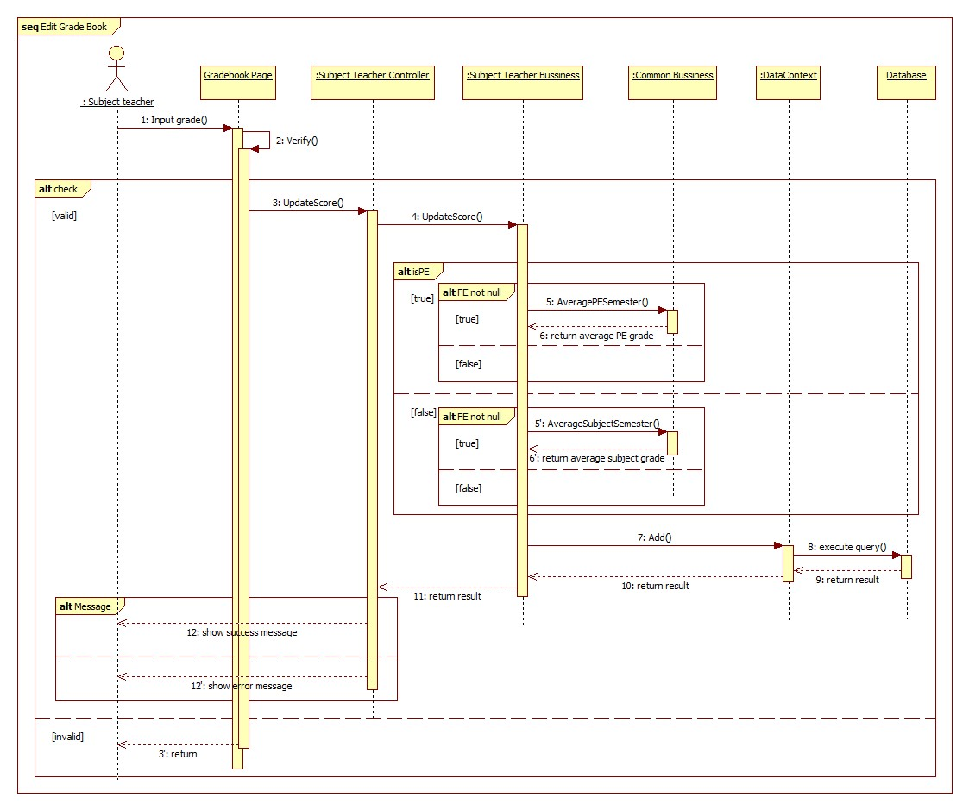

Figure 51: Sequence Diagram <Subject Teacher> Edit Gradebook

#### <Homeroom Teacher> Approve Absence Request

**Summary:** This diagram shows how homeroom teacher approve absence request form.



Figure 52: Sequence Diagram <Homeroom Teacher> Approve Absence Request

#### <Homeroom Teacher> Disapprove Absence Request

**Summary:** This diagram shows how homeroom teacher disapprove absence request.



Figure 53: Sequence Diagram <Homeroom Teacher> Disapprove Absence Request

#### <Homeroom Teacher> Evaluate Behavior

**Summary:** This diagram shows how homeroom teacher evaluate behavior.

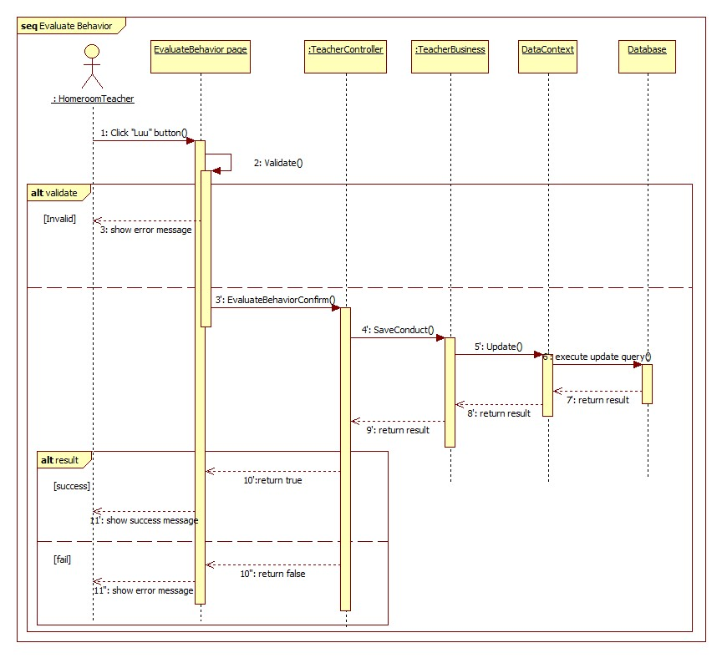

Figure 54: Sequence Diagram <Homeroom Teacher> Evaluate Behavior

#### <Student’s Parent> Send Absence Request

**Summary:** This diagram shows how student’s parent sent absence request.

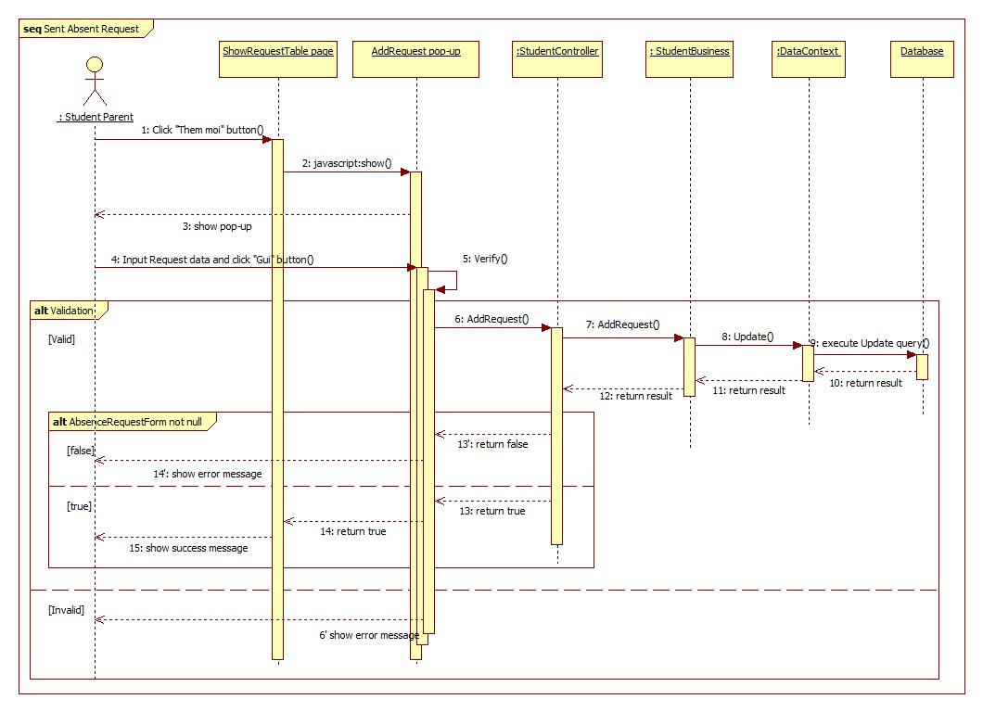

Figure 55: Sequence Diagram <Student’s Parent> Send Absence Request

## User Interface Design

### Guest Interface Design

#### Login

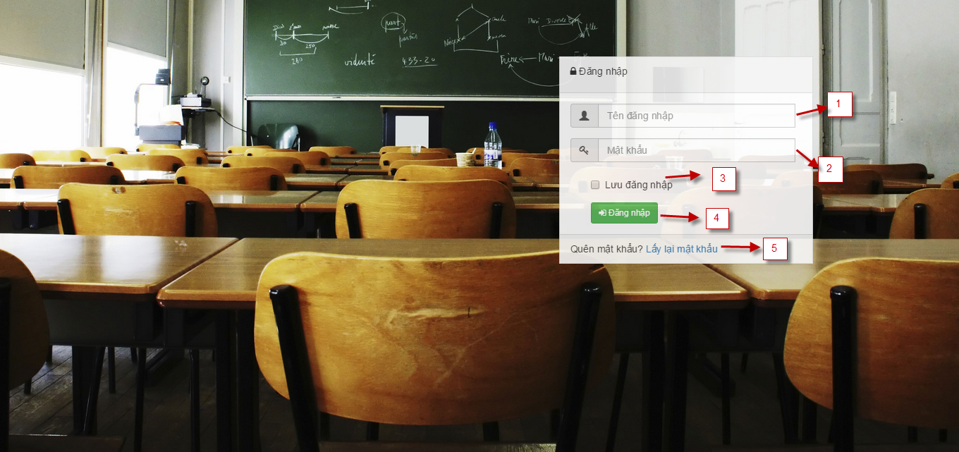

Figure 56: Login Page

**Fields**

|  |  |  |  |  |  |  |  |
| --- | --- | --- | --- | --- | --- | --- | --- |
| No | Field  Name | Description | Read  only | Mandatory | Control  Type | Data  Type | Length |
| 1 | Username | Fill username | No | Yes | Textbox | String | N/A |
| 2 | Password | Fill password | No | Yes | Password | String | N/A |
| 3 | Remember account | Check to remember username and password | No | No | Checkbox | Boolean | N/A |

**Buttons/Hyperlinks**

|  |  |  |  |  |
| --- | --- | --- | --- | --- |
| **No** | **Function** | **Description** | **Validation** | **Outcome** |
| 4 | Forgot password | Click when user forgot password | No | Show pop-up forgot password page |
| 5 | Login | Click to login into system | Yes | Navigate to appropriate page |

#### Admin Home Page

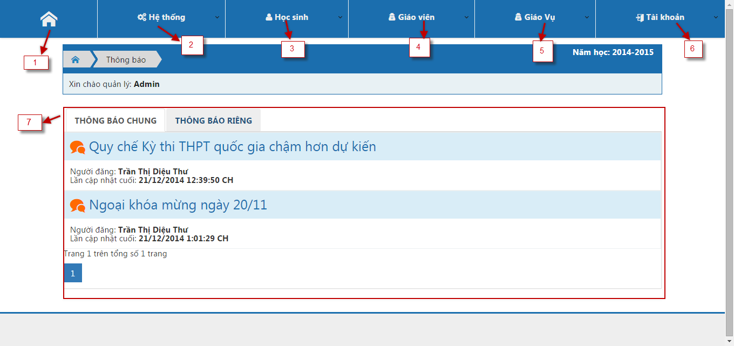

Figure 57: Admin Home Page

**Fields**

|  |  |  |  |  |  |  |  |
| --- | --- | --- | --- | --- | --- | --- | --- |
| No | Field  Name | Description | Read  only | Mandatory | Control  Type | Data  Type | Length |
| 2 | System | Click to show drop down list system function | No | No | Drop down | N/A | N/A |
| 3 | Student | Click to show drop down list student function | No | No | Drop down | N/A | N/A |
| 4 | Teacher | Click to show drop down list teacher function | No | No | Drop down | N/A | N/A |
| 5 | Staff | Click to show drop down list staff function | No | No | Drop down | N/A | N/A |
| 6 | Account | Click to show drop down list system function | No | No | Drop down | N/A | N/A |
| 7 | Announcement | Click show public and private announcement | Yes | No | Tab | N/A | N/A |

**Buttons/Hyperlinks**

|  |  |  |  |  |
| --- | --- | --- | --- | --- |
| **No** | **Function** | **Description** | **Validation** | **Outcome** |
| 1 | Home | Show home page | No | Show index home page of admin |

#### School Year List

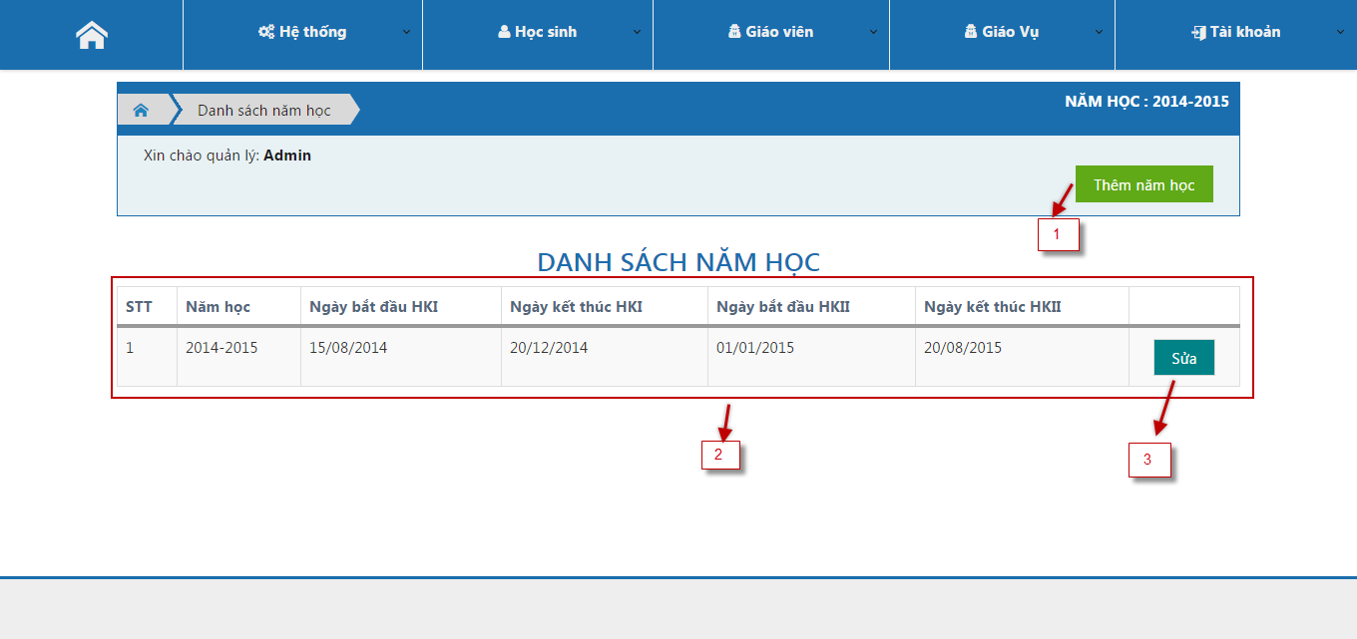

Figure 58: School Year List Page

**Fields**

|  |  |  |  |  |  |  |  |
| --- | --- | --- | --- | --- | --- | --- | --- |
| No | Field  Name | Description | Read  only | Mandatory | Control  Type | Data  Type | Length |
| 2 | School year table | Show all school year | Yes | Yes | Table | String | N/A |

**Buttons/Hyperlinks**

|  |  |  |  |  |
| --- | --- | --- | --- | --- |
| **No** | **Function** | **Description** | **Validation** | **Outcome** |
| 1 | Create new | Click create new school year | No | Show pop-up create new school year |
| 3 | Edit | Click edit school year | No | Show pop-up edit school year |

#### Add New School Year

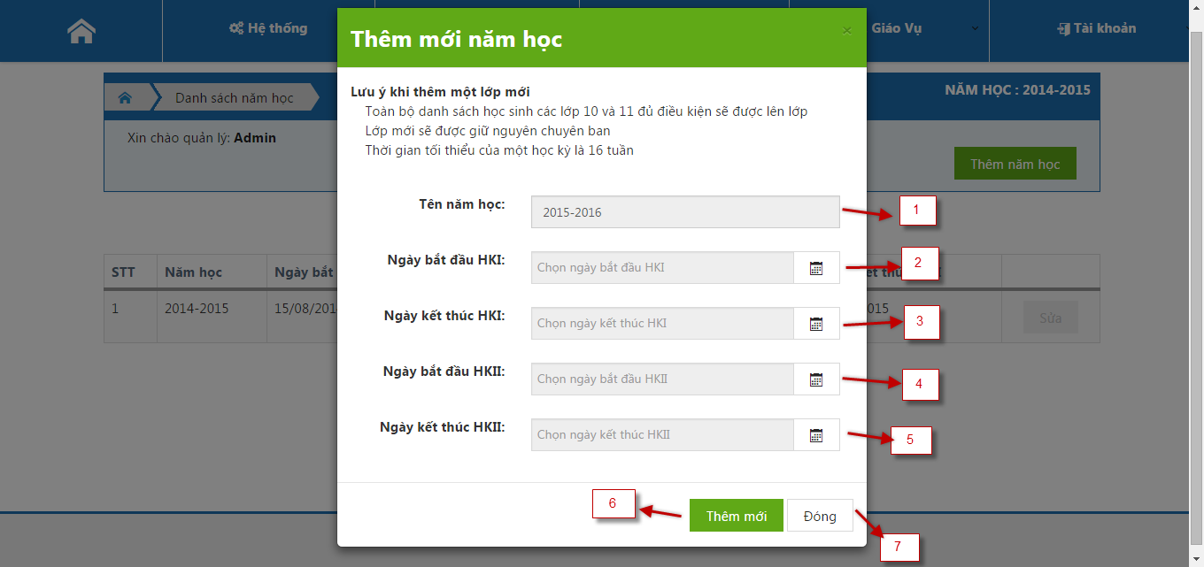

Figure 59: Add New School Year Page

**Fields**

|  |  |  |  |  |  |  |  |
| --- | --- | --- | --- | --- | --- | --- | --- |
| No | Field  Name | Description | Read  only | Mandatory | Control  Type | Data  Type | Length |
| 1 | School year name | Fill name of school year | No | Yes | Text box | String | N/A |
| 2 | Start date 1st semester | Select date time of start date 1st semester | No | Yes | Date picker | Date | N/A |
| 3 | End date 1st semester | Select date time of end date 1st semester | No | Yes | Date picker | Date | N/A |
| 4 | Start date 2nd semester | Select date time of start date 2nd semester | No | Yes | Date picker | Date | N/A |
| 5 | End date 1st semester | Select date time of end date 2nd semester | No | Yes | Date picker | Date | N/A |

**Buttons/Hyperlinks**

|  |  |  |  |  |
| --- | --- | --- | --- | --- |
| **No** | **Function** | **Description** | **Validation** | **Outcome** |
| 6 | Create new | Click create new school year | Yes | Add new school year and close pop-up |
| 7 | Close | Click cancel add school year | No | Close pop-up |

#### Teacher List

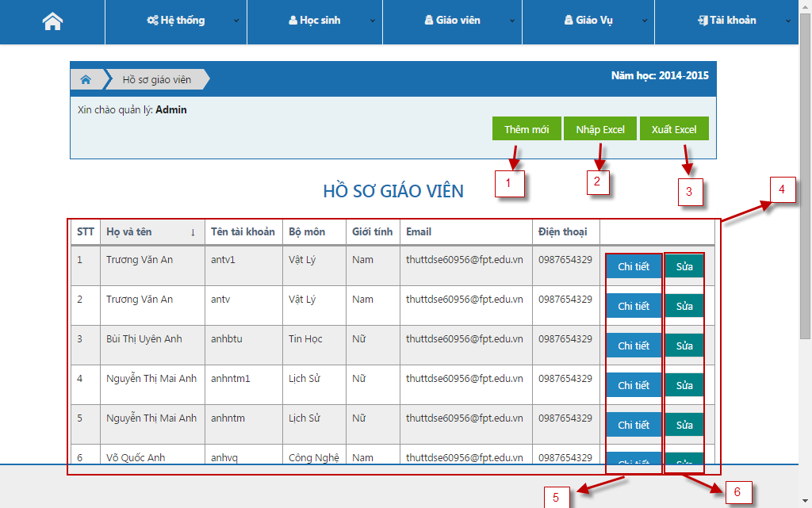

Figure 60: Teacher List Page

**Fields**

|  |  |  |  |  |  |  |  |
| --- | --- | --- | --- | --- | --- | --- | --- |
| No | Field  Name | Description | Read  only | Mandatory | Control  Type | Data  Type | Length |
| 4 | Teacher table | Show teacher in a school | Yes | Yes | Table | String | N/A |

**Buttons/Hyperlinks**

|  |  |  |  |  |
| --- | --- | --- | --- | --- |
| **No** | **Function** | **Description** | **Validation** | **Outcome** |
| 1 | Create new teacher | Click create new teacher | No | Show pop-up create new teacher |
| 2 | Import Excel | Click to up excel file into system | No | Navigate to import teacher page |
| 3 | Export Excel | Click to download data of system | No | Download file excel |
| 5 | View detail | Click to view detail a teacher | No | Show pop-up information of teacher page |
| 6 | Edit | Click to edit a teacher | No | Show pop-up edit teacher page |

#### Class List

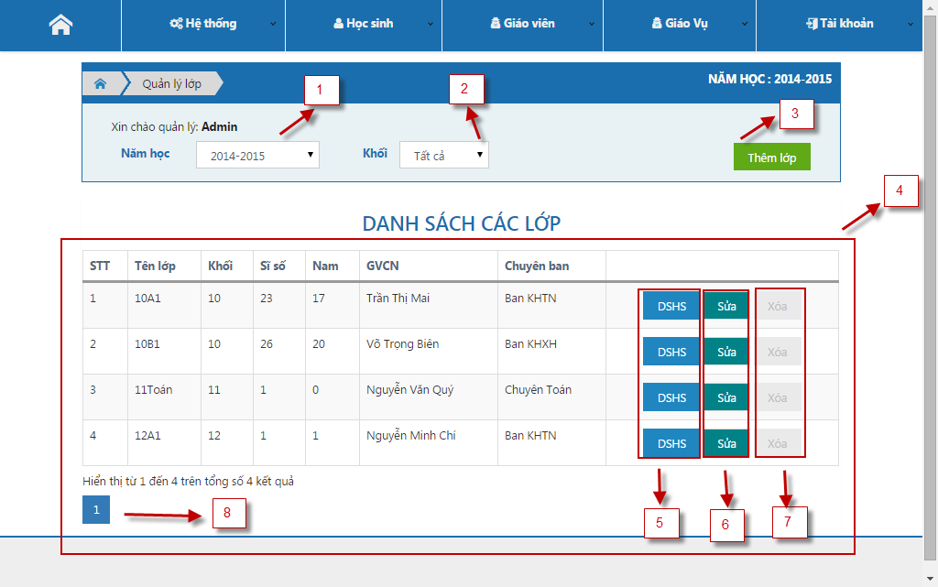

Figure 61: Class List Page

**Fields**

|  |  |  |  |  |  |  |  |
| --- | --- | --- | --- | --- | --- | --- | --- |
| No | Field  Name | Description | Read  only | Mandatory | Control  Type | Data  Type | Length |
| 4 | Class in school year table | Show all classes in current school year | Yes | Yes | Table | String | N/A |

**Buttons/Hyperlinks**

|  |  |  |  |  |
| --- | --- | --- | --- | --- |
| **No** | **Function** | **Description** | **Validation** | **Outcome** |
| 1 | Get class table by year | Select school year name | No | Refresh table with appropriate data |
| 2 | Get table by grade | Select grade school year | No | Refresh table with appropriate data |
| 3 | Create new class | Click create new class | No | Show pop-up create class page |
| 5 | View detail class | Click to view detail a class | No | Show pop-up view detail class page |
| 6 | Edit class | Click to edit class | No | Show pop-up edit class page |
| 7 | Delete class | Click to remove a class | No | Show pop-up remove class page |
| 8 | Pagination | Click to show next data table | No | Next data table is showed |

#### Student List of Class

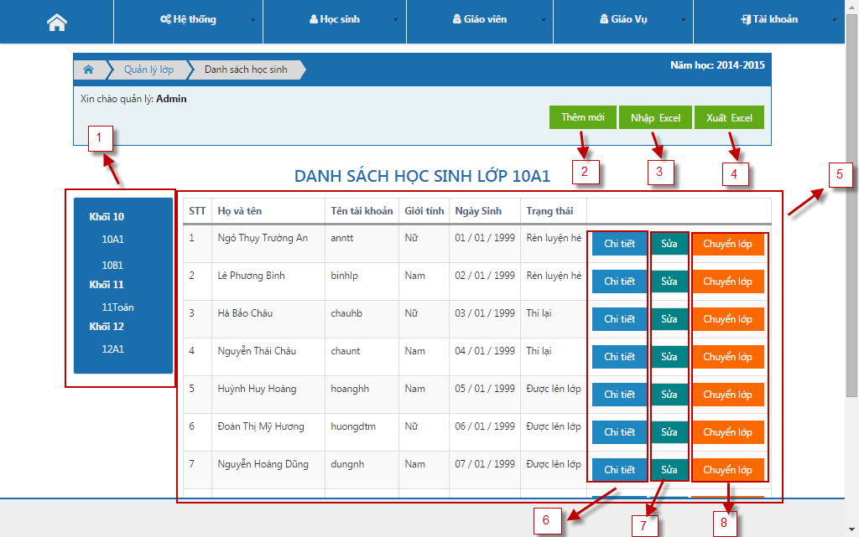

Figure 62: Student List of Class Page

**Fields**

|  |  |  |  |  |  |  |  |
| --- | --- | --- | --- | --- | --- | --- | --- |
| No | Field  Name | Description | Read  only | Mandatory | Control  Type | Data  Type | Length |
| 5 | Student in a class table | View all students in a year | Yes | Yes | Table | String | N/A |

**Buttons/Hyperlinks**

|  |  |  |  |  |
| --- | --- | --- | --- | --- |
| **No** | **Function** | **Description** | **Validation** | **Outcome** |
| 1 | Get class in grade school | Click a class is a grade | No | Show Student in a class table |
| 2 | Create new | Click edit school year | No | Show pop-up edit school year |
| 3 | Import Excel | Click to up excel file | No | Navigate to import student page |
| 4 | Export Excel | Click to download data of system | No | Download file excel |
| 6 | View Detail | Click to view detail a student | No | Show pop-up detail student page |
| 7 | Edit | Click to edit a student | No | Show pop-up edit student page |
| 8 | Transfer class | Click to change current class to another class | No | Show pop-up transfer class page |

#### Assign Teaching

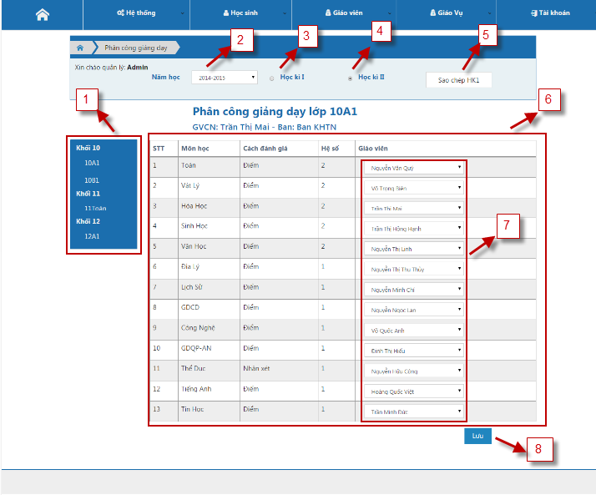

Figure 63: Assign Teaching Page

**Fields**

|  |  |  |  |  |  |  |  |
| --- | --- | --- | --- | --- | --- | --- | --- |
| No | Field  Name | Description | Read  only | Mandatory | Control  Type | Data  Type | Length |
| 6 | Assign teacher table | Show list assign teacher | Yes | Yes | Table | String | N/A |
| 7 | Teacher list | Select a teacher for a subject of class | No | Yes | Drop down list | String | N/A |

**Buttons/Hyperlinks**

|  |  |  |  |  |
| --- | --- | --- | --- | --- |
| **No** | **Function** | **Description** | **Validation** | **Outcome** |
| 1 | Get class in grade school | Click a class of grade | No | Show assign teacher table |
| 2 | Get assign teacher table by school year | Select a year name | No | Refresh and get new data |
| 3 | Get assign teacher table by 1st semester | Check 1st semester | No | Refresh and get new data |
| 4 | Get assign teacher table by 2nd semester | Check 2nd semester | No | Refresh and get new data |
| 5 | Copy data | Click copy assign teacher of semester | Yes | Copy assign teacher of 1st semester |
| 8 | Save | Click to save assign teacher | Yes | Save data and show success message |

#### Manage Account

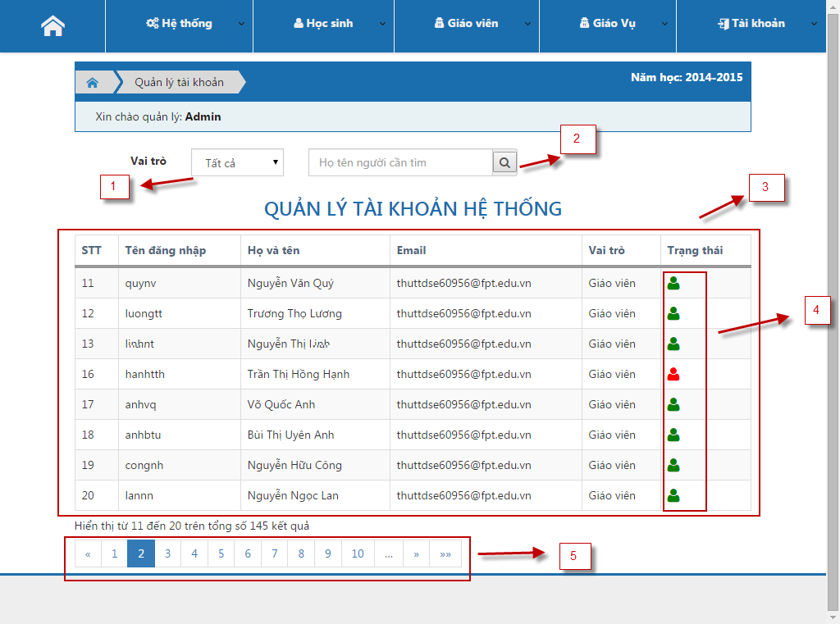

Figure 64: Manage Account Page

**Fields**

|  |  |  |  |  |  |  |  |
| --- | --- | --- | --- | --- | --- | --- | --- |
| No | Field  Name | Description | Read  only | Mandatory | Control  Type | Data  Type | Length |
| 3 | Manage account table | Show all account in system | Yes | Yes | Table | String | N/A |

**Buttons/Hyperlinks**

|  |  |  |  |  |
| --- | --- | --- | --- | --- |
| **No** | **Function** | **Description** | **Validation** | **Outcome** |
| 1 | Get list accounts by role | Select a role in system | No | Refresh and show new data by role |
| 2 | Search an account | Fill and click to search an account | No | Refresh and show result of search |
| 4 | Status | Click to change status | No | Save status and change color of account |
| 5 | Pagination | Click to view next data | No | Refresh and show new data |

#### Manage Announcement

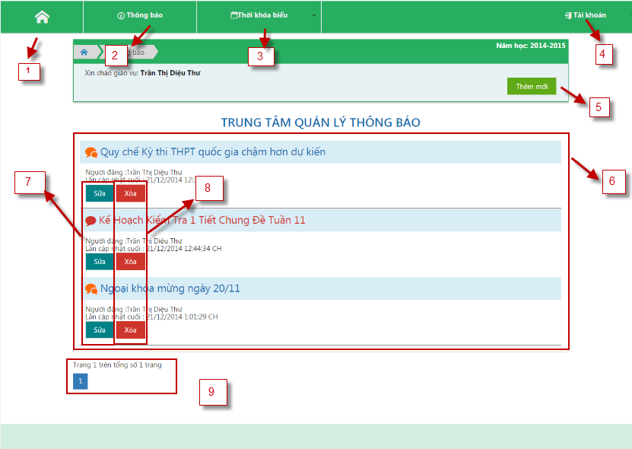

Figure 65: Manage Announcement Page

**Fields**

|  |  |  |  |  |  |  |  |
| --- | --- | --- | --- | --- | --- | --- | --- |
| No | Field  Name | Description | Read  only | Mandatory | Control  Type | Data  Type | Length |
| 2 | Manage announcement | Click to select announcement function | No | No | Drop down list | N/A | N/A |
| 3 | Schedule | Click to select schedule function | No | No | Drop down list | N/A | N/A |
| 4 | Account | Click to select account function | No | No | Drop down list | N/A | N/A |
| 6 | Announcement table | Show public and private announcement | No | No | Accordion | N/A | N/A |

**Buttons/Hyperlinks**

|  |  |  |  |  |
| --- | --- | --- | --- | --- |
| **No** | **Function** | **Description** | **Validation** | **Outcome** |
| 1 | Home | Show home page | No | Show index home page of Staff |
| 5 | Create new | Click to create new announcement | No | Show pop-up create new announcement page |
| 7 | Edit | Click to edit an announcement | No | Show pop-up edit announcement page |
| 8 | Delete | Click to delete an announcement | No | Show pop-up delete announcement page |
| 9 | Pagination | Click to view next data | No | Refresh and show new data |

#### Manage Schedule

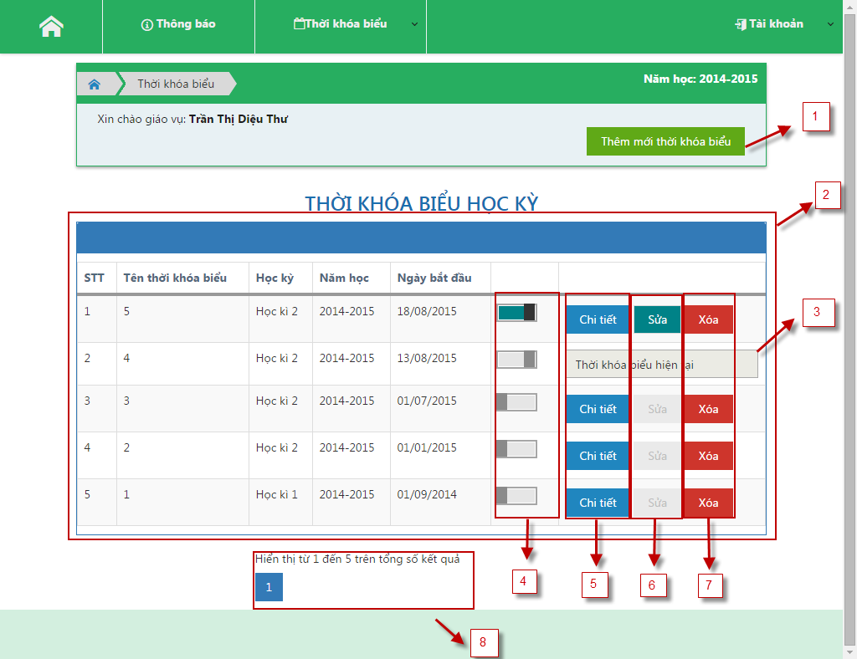

Figure 66: Manage Schedule Page

**Fields**

|  |  |  |  |  |  |  |  |
| --- | --- | --- | --- | --- | --- | --- | --- |
| No | Field  Name | Description | Read  only | Mandatory | Control  Type | Data  Type | Length |
| 2 | Schedule list table | View all schedule in a year | Yes | Yes | Table | String | N/A |
| 3 | Schedule current | Schedule is used for all class at the present | Yes | Yes | Text | String | N/A |

**Buttons/Hyperlinks**

|  |  |  |  |  |
| --- | --- | --- | --- | --- |
| **No** | **Function** | **Description** | **Validation** | **Outcome** |
| 1 | Create new | Click to add new schedule | No | Show pop-up create schedule page |
| 4 | Change status | Scroll to change status of schedule | No | Save status into data and change color in user interface |
| 5 | View detail schedule | Click to view detail of schedule | No | Show pop-up detail schedule page |
| 6 | Edit | Click to edit a schedule | No | Show pop-up edit schedule page |
| 7 | Delete | Click to delete a schedule | No | Show pop-up Delete schedule page |
| 8 | Pagination | Click to view next data | No | Refresh and show new data |

#### Statistic of Grade

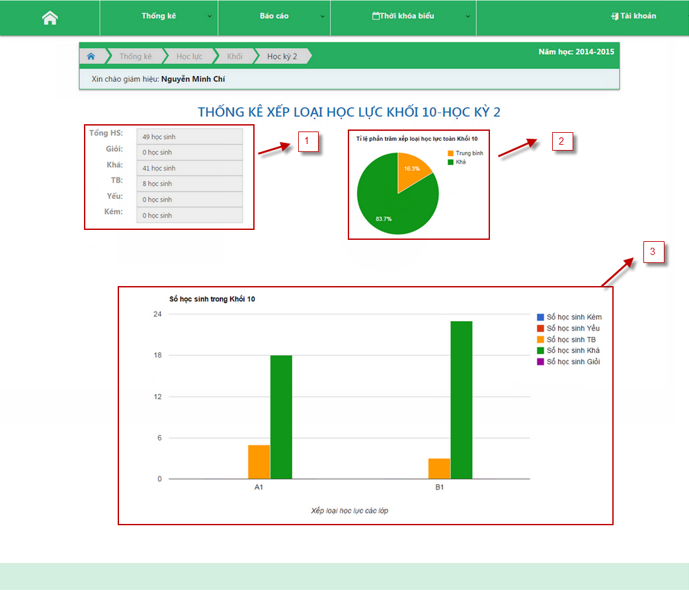

Figure 67: Statistic of Grade Page

**Fields**

|  |  |  |  |  |  |  |  |
| --- | --- | --- | --- | --- | --- | --- | --- |
| No | Field  Name | Description | Read  only | Mandatory | Control  Type | Data  Type | Length |
| 1 | Summary of class | View all result of student | Yes | Yes | N/A | N/A | N/A |
| 2 | Pie chart | View present result of student | Yes | Yes | N/A | N/A | N/A |
| 3 | Bar chart | View all result of student | Yes | Yes | N/A | N/A | N/A |

**Buttons/Hyperlinks:** N/A

## Database Design

### Logical Diagram

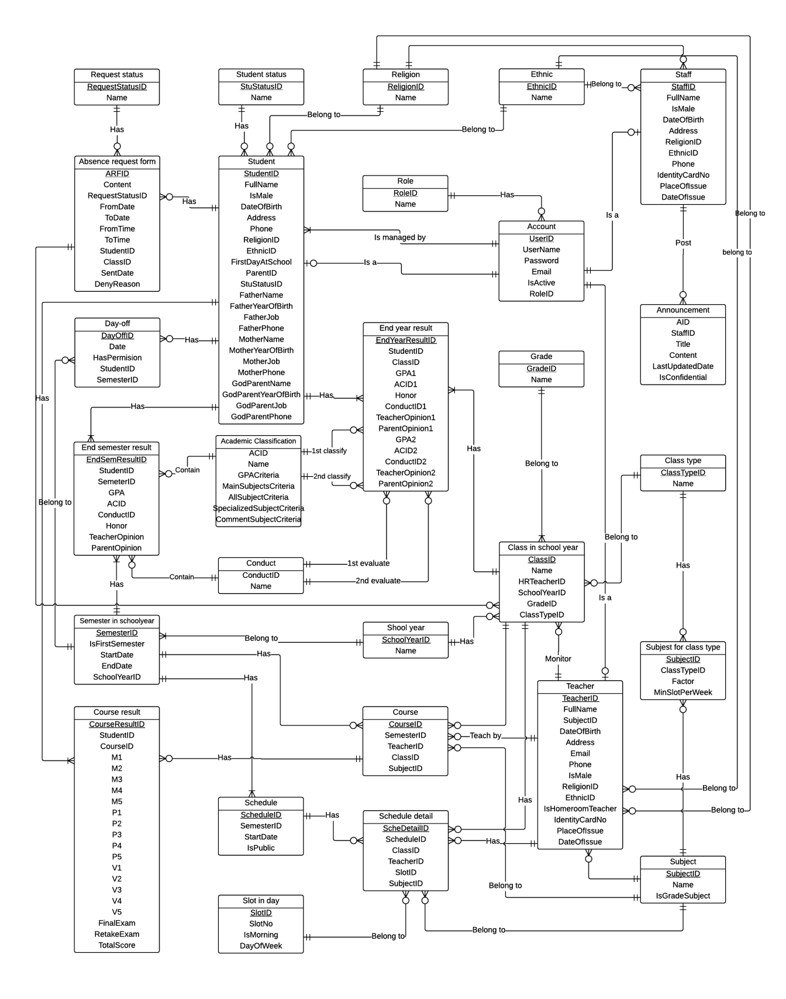

Figure 68: Logical Diagram

### Data Dictionary

Please refer full document in CD.

## Algorithms

Academic classification, considering honor and upgrading methods are based on the circular “58/2011/TT-BGDĐT” of the Ministry of Education and Training.

### Academic classification

There are 5 type of academic classification: “Giỏi” (very good), “Khá” (good), “TB” (mean), “Yếu” (bad), “Kém” (very bad). Classification method for each type is based on 5 criteria:

* GPA
* Math’s total score or Literature’s total score
* All grade subject total score
* Specialized subject’s total score (in case of specialized class)
* Comment subject

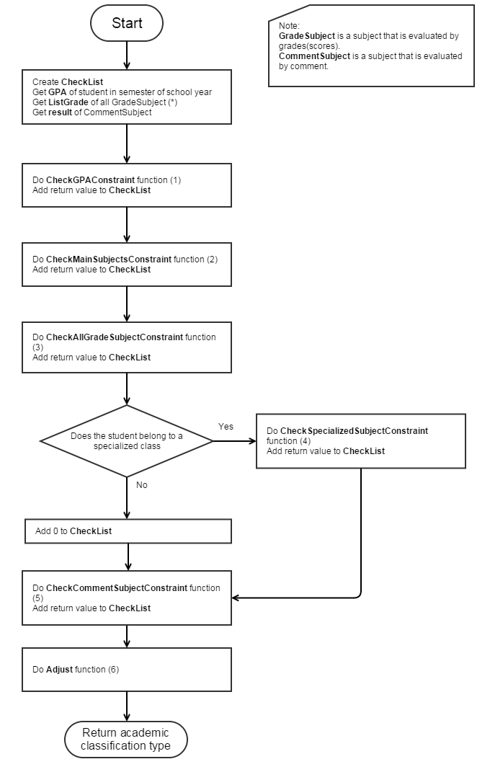

Figure 69: Academic classification main flow

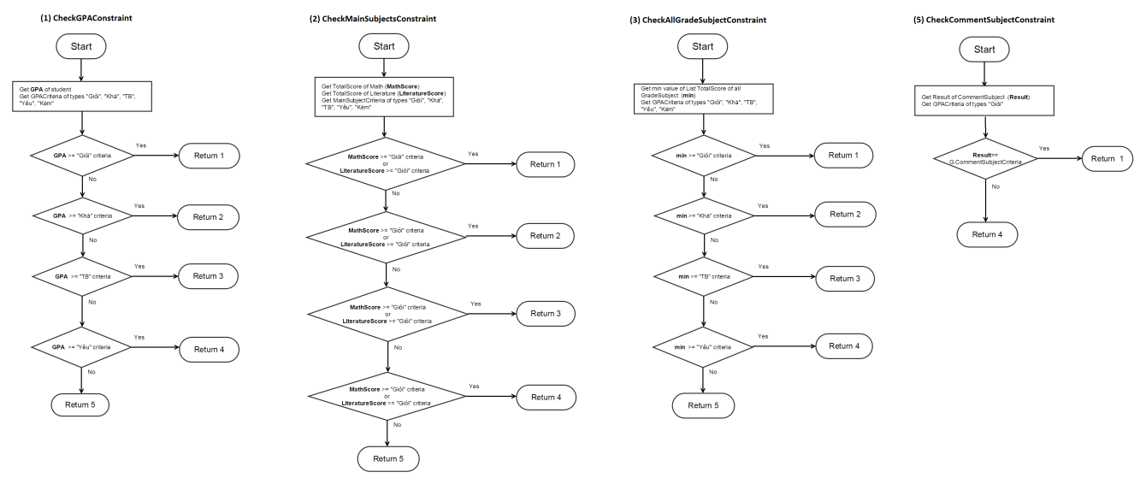

Figure 70: Academic classification sub-flow 1, 2, 3, 5

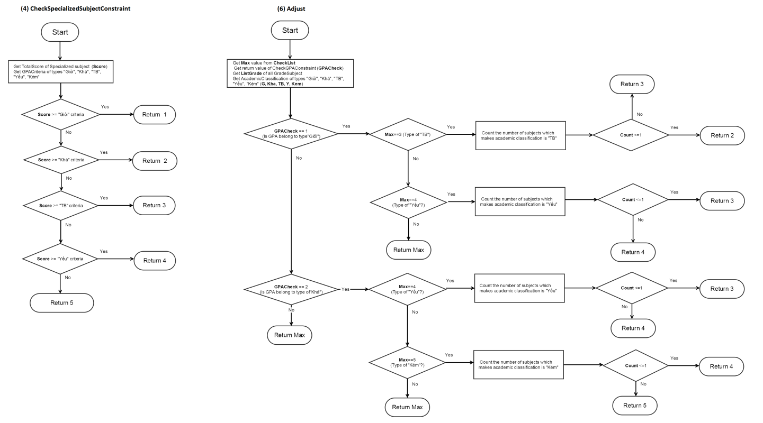

Figure 71: Academic classification sub-flow 4, 6

### Consider of honor

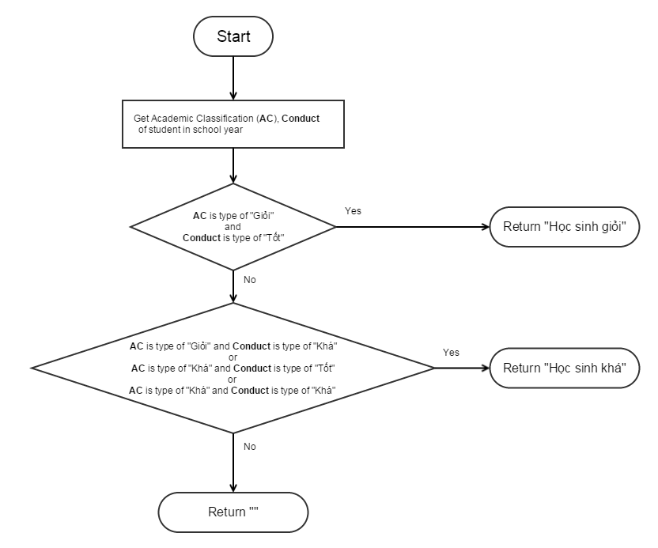

Figure 72: Consider Honor

### Consider of upgrading

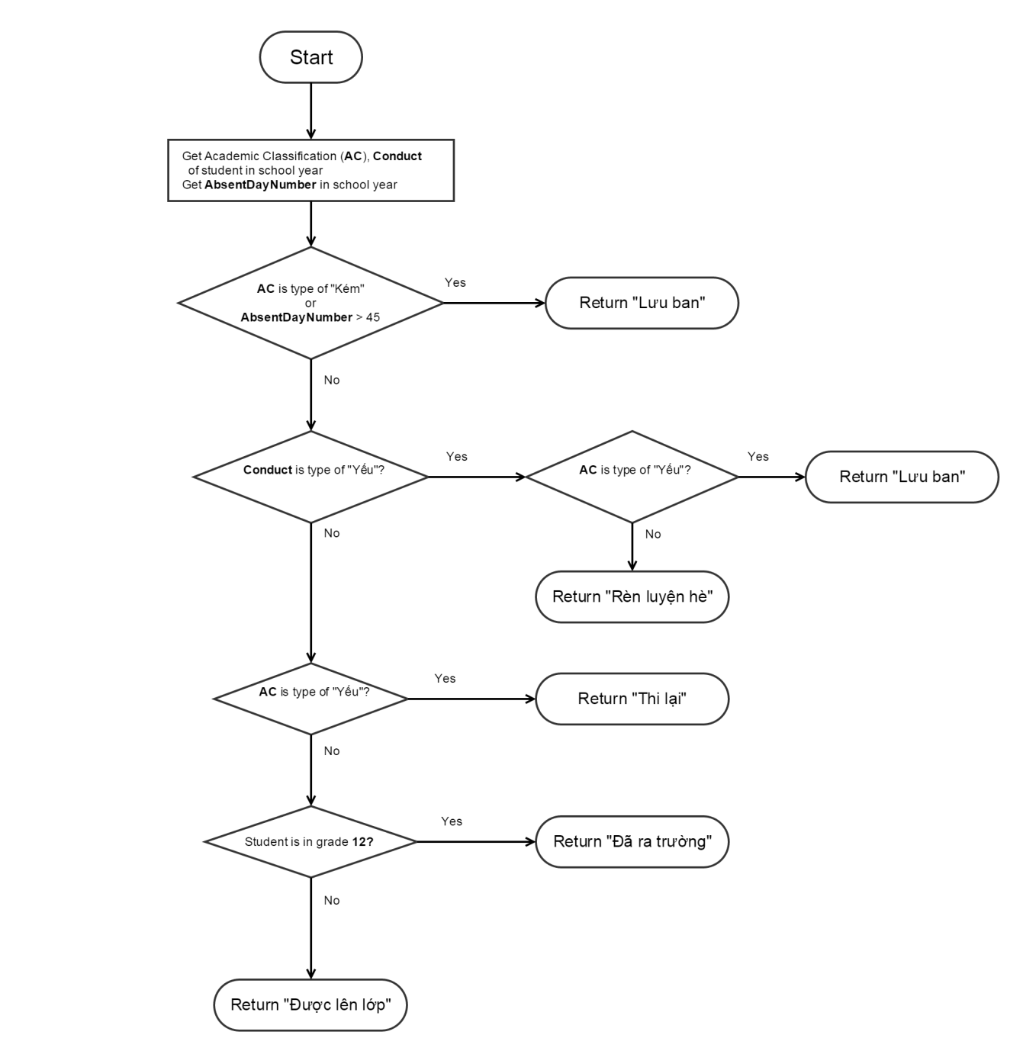

Figure 73: Consider Upgrading

### State Machine Diagram for Student Status

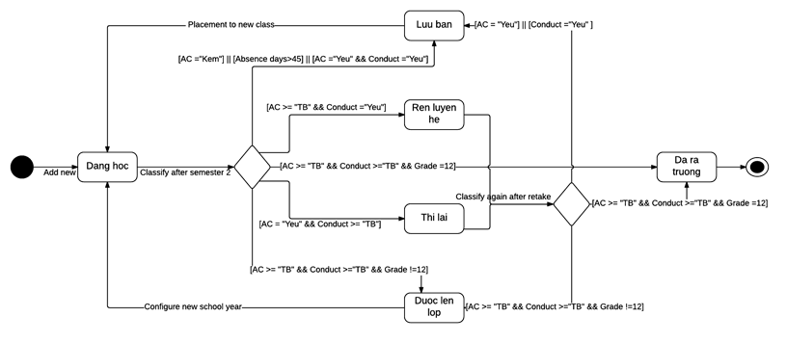

Figure 74: State Machine Diagram for Student Status

### State Machine Diagram for Request Status

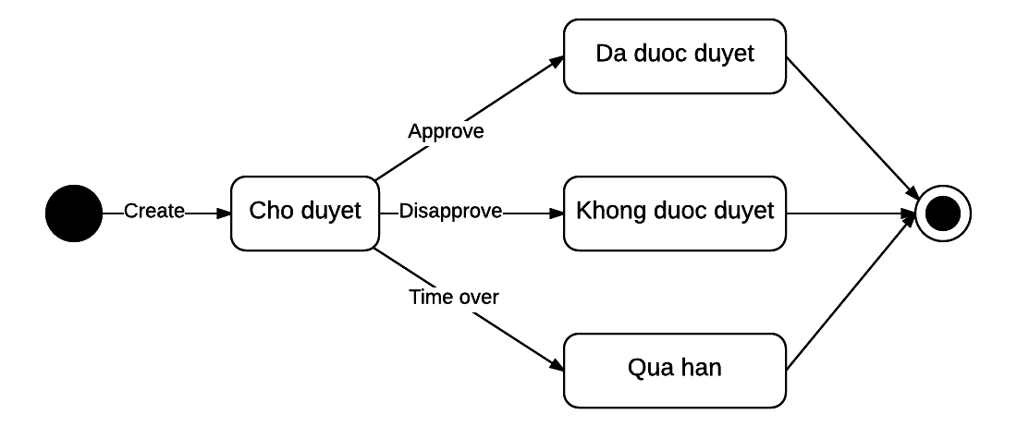

Figure 75: State Machine Diagram for Request Status